

Faculty of Science and Engineering

School of Computing and Information Science

**Module MOD009295:**

**Advanced Relational Database Development**

**Element 010**

**Report**

**SID NUMBER: 2218952**

Submission deadline: 11/04/2025

**Table of Contents**

**Section 1: Project Proposal** 2

**1.1 Business Overview** 3

**1.2 Operations and Data Flow** 3

**1.3 Database Roles and Users** 4

**1.4 Business-Related Questions** 4

**Section 2: Database Design and Implementation** 6

**2.1 Entity List** 6

**2.2 Conceptual Model** 8

**2.3 Logical Model** 10

**2.4 Database Schema** 12

**2.5 Implementation** 12

**Section 3: Query Design, Construction and Testing** 27

**3.1 Query 1** 27

**3.2 Query 2** 29

**3.3 Query 3** 31

**3.4 Query 4** 33

**3.5 Query 5** 35

**Section 4: SQL Programming** 37

**4.1 Procedure 1** 37

**4.2 Procedure 2** 40

**4.3 Procedure 3** 42

**4.4 Trigger 1** 44

**4.5 Trigger 2** 47

**References** 50

**Appendix I: Database Schema** 53

**Appendix II: SQL Explanation** 61

# **Section 1: Project Proposal**

**Title: Airline Flight Management Database**

## **1.1 Business Overview**

Airlines depend on effective data management systems to manage data related to flights, passengers, ticketing, baggage tracking, crew scheduling, and financial transactions. Without a systematic process, airlines would experience booking errors, flight conflicts, and operational inefficiencies (Belobaba et al., 2009). An Airline Flight Management Database is designed to manage airline operations and improve overall efficiency. It keeps in one place all critical data related to airports, airlines, aircrafts, flights, passengers, tickets, payments, crew and schedules, baggage handling, delays, and cancellations.

## **1.2 Operations and Data Flow**

The data processing in the Airline Flight Management Database is performed through a set of interconnected operations. Each flight is recorded with details of departure and arrival airports, airline, aircraft, and schedule. When a passenger makes a reservation, information such as name, passport number, seat assignment, and class of travel is recorded along with the flight details. The system also records payments and links them to the corresponding ticket number. In aviation, crew scheduling assigns flights to the correct duty with the assigned date and hours worked within that schedule (Barnhart et al., 2003). The system will also store baggage data that is tagged and linked to passenger tickets. If the delays or cancellations take place, records will get updated with dates and reasons.

**1.3 Database Roles and Users**

This system will have different user roles that interact with the system according to their responsibilities. Airline staff will manage flights, aircraft and crew assignments. Passengers will have access to ticket information, payment records, and flight status. Ground staff manage baggage tracking and flight information to ensure proper handling. Finance departments process ticket payments and revenues to ensure proper revenue tracking. IT administrators maintain database security, system performance and prevent data inconsistencies to ensure system reliability. The Airline Flight Management Database simplifies the work in smooth coordination to effectively assist both airlines and passenger services.

## **1.4 Business-Related Questions**

1. How does total flight revenue vary across different seasons (winter, spring, summer, fall), and which season generates the highest overall revenue across all airlines?

2. Who are the highest-spending passengers, and what are their spending patterns in terms of flight frequency and preferred airline?

3. Which flight routes generate the highest revenue, and how many tickets are sold on these routes?

4. Which airports experience the highest volume of flight traffic in terms of departures and arrivals?

5. Which airlines experience the highest number of delays and cancellations, and what percentage of their total flights are affected?

# **Section 2: Database Design and Implementation**

## **2.1 Entity List**

The Airline Flight Management Database is made up of structured entities that store and manage important airline information. The entities were chosen based on basic airline operations to make the system useful in managing flights, passenger services, crew schedules, and finances.

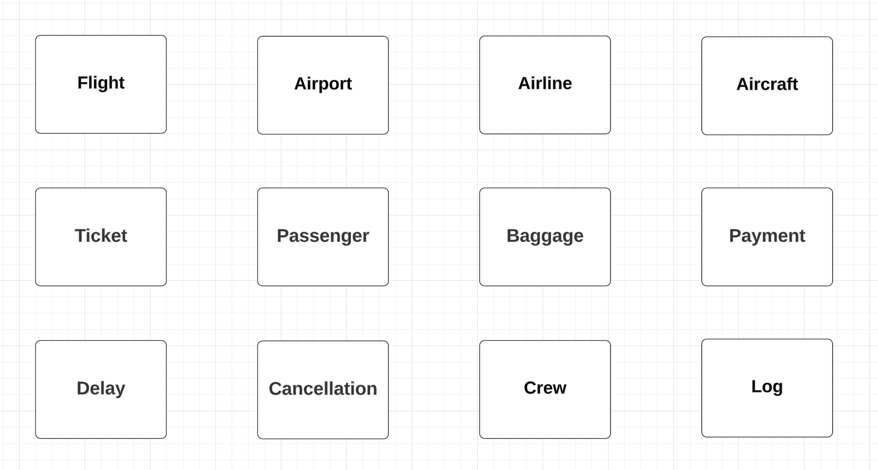

The airport entity holds key details about airports like name, city, country, IATA and ICAO codes (Carlson, 2021), and time zone. The details are required to understand where flights start and end. The airline entity shows the operating airlines in the system, helping sort flights and monitor the performance of airlines. The aircraft entity holds data about each aircraft, including the model, manufacturer, registration number, total capacity, and flight range. The flight entity records flight details such as departure and arrival airports, airline, aircraft, schedule. This entity connects other entities like tickets, baggage, payments, delays, and cancellations, as all these depend on flight operations.

The passenger entity tracks information like personal details, nationality, and contact details of the passengers. It helps with ticket booking and passenger identification. The ticket entity is for flight reservations. It connects passengers with their flights and monitors booking details, seat assignment, travel class, and price. The baggage entityincludes details about weight and type of the baggage (carry-on or check-in). The payment entity handles money transactions. It monitors payments for tickets by the passengers, like how they paid and the amount (after taxes).

The crew entity maintains information about flight staff, including pilots, flight attendants, and engineers, to ensure that the right people are assigned to flights. The delay entity maintains delays for flights, what they were due to, how long they last, and when they happened, helpful in reporting operations and trends impacting on-time arrivals. The cancellation entity holds data about cancelled flights with reasons and cancellation dates, helpful in analysing the disruption to flights. The log entity stores the history of changes made to some tables.

Gate and Terminal entities were also considered, but excluded because they are dynamically assigned to flights and can change frequently. Managing them as static entities would not reflect real-time operations accurately. Instead, they are handled operationally by airport systems rather than stored permanently in the database.

## **2.2 Conceptual Model**

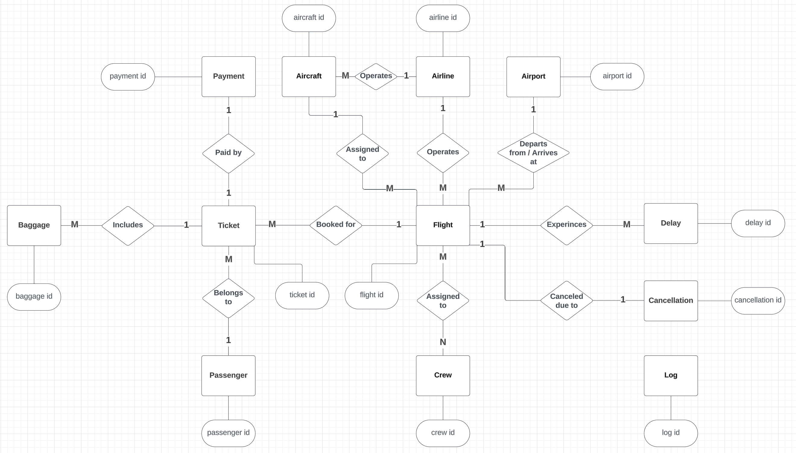

The conceptual design of the Airline Flight Management Database shows the relationships between entities and their cardinalities.

Airlines operate multiple flights, but every flight belongs to a single airline (M:1). Similarly, one flight belongs to one aircraft, but one aircraft is scheduled for numerous flights over time (M:1). The aircraft entity is related to the airline in a many-to-one (M:1) relationship since one airline company may own or operate multiple aircraft, but each aircraft is associated with just one airline company. Flights depart from and arrive at specific airports, creating a many-to-one (M:1) relationship where each flight is linked to two airports. This was initially a design problem because a straightforward many-to-one (M:1) relationship between airport and flight would not show the difference between arrival and departure places. This was fixed in the Logical Model by adding 2 foreign keys in the flight table.

There are multiple tickets on a flight, but a ticket belongs to one flight (1:M). Each ticket belongs to one passenger in an (M:1) relationship because the passenger can have more than one ticket (for instance, different flight tickets). A ticket can have more than one baggage, so there is a one-to-many (1:M) relationship. Each ticket is also going to have a payment, so there is a one-to-one (1:1) relationship so that each ticket has its own transaction record/date.

Several delays can happen to one flight because of different reasons, that's why it has a one-to-many (1:M) relationship. However, cancellation is a single event, and thus it has a one-to-one (1:1) relationship between a flight table (is either cancelled or not). Crew management is designed through a many-to-many (M:N) relationship between flight and crew (in the Logical Model, it will have a connection table). This enables more than one crew member to be assigned to one flight, and it also enables crew members to work on another flight at a different time. The log entity is not related to any specific entity, because it is specifically designed for creating triggers that record changes in various tables (this table can be connected to all entities if the task is to keep a record of modifications for all tables).

## **2.3 Logical Model**

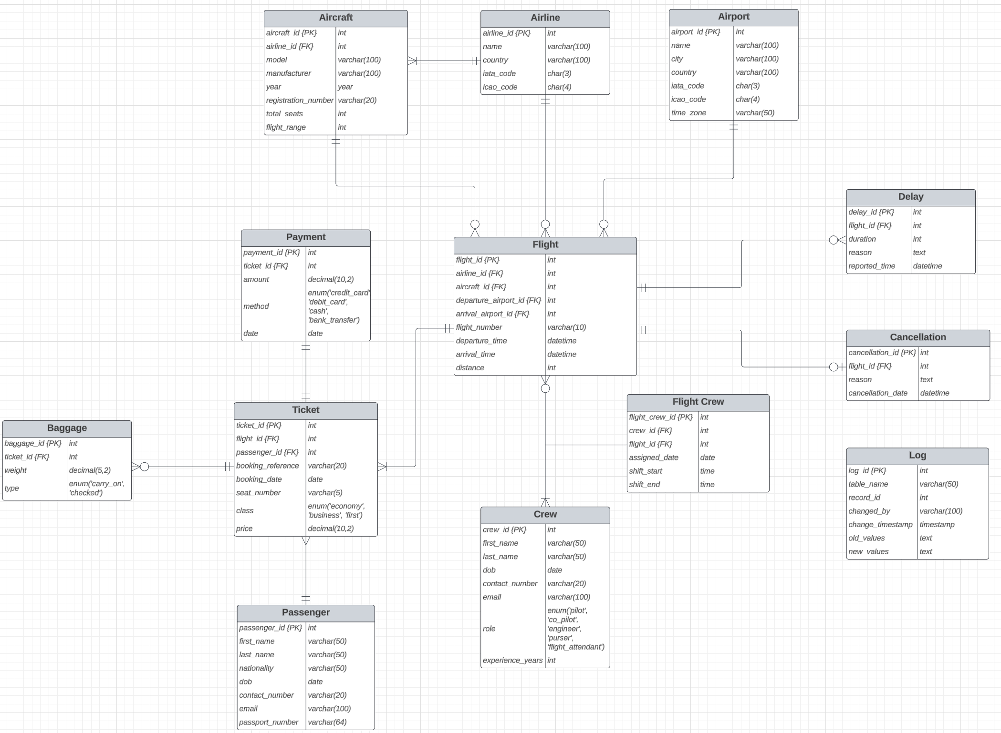

The Logical Model transforms the conceptual design into a relational schema that can be implemented by specifying tables, attributes, and relationships.

A main problem that was faced during designing phase was the many-to-one (M:1) relationship between airport and flight. A direct association between flight and airport did not initially distinguish departure and arrival locations, which could cause problems later. This was fixed by adding two foreign keys (arrival_airport_id and departure_airport_id) in the flight table, so that each flight has a clear departure and arrival point.

Another challenge was handling crew management. As a flight has several crew members, and a crew member can be on several flights, a many-to-many (M:N) relationship was needed. This issue was fixed by creating a connection table called "Flight Crew" that assigns crew members to flights with additional attributes (assigned date, shift start, and shift end).

All normalization forms were applied to the database scheme to eliminate redundancy. First Normal Form (1NF) was applied by making sure there were no multi-valued fields in the database. For instance, instead of storing several baggage items into a single field, an independent baggage table was established to have a one-to-many (1:M) relationship with ticket. The Second Normal Form (2NF) was applied by making sure that all non-key attributes are fully functionally dependent on the primary key. For example, in the flight table, aircraft-related data was not stored directly but by reference using the aircraft_id (foreign key), thus avoiding redundant holding of aircraft-related information. To achieve Third Normal Form (3NF) all dependencies that indirectly relied on non-key attributes were removed. Specifically, passenger details are stored in the passenger table instead of the ticket table, so that passenger details are independent of non-key attributes such as booking reference.

## **2.4 Database Schema**

Due to the word limit, the database schema is provided in Appendix I (Database Schema) instead of the main report.

## **2.5 Implementation**

While building the database, more MySQL keywords were added to make the design better. The UNIQUE keyword does not allow the insertion of the same data twice for columns like iata_code, icao_code, email, and passport_number and others. The NOT NULL keyword makes columns always have data. The CHECK keyword makes sure that attributes like total_seats, flight_range, and price are sensible. The ON DELETE CASCADE keyword was used to automatically remove associated data when a parent record is deleted. ENUM data types were also used for attributes like ticket class, baggage type, and payment type so that only specific allowed values are used.

For clarity and readability, each database table's schema, inserted data, and corresponding screenshots are displayed on separate pages. The screenshots for each table display the first 20 rows of inserted data for demonstration purposes. In reality, the database contains more records, which can be fully accessed in the “data.sql” file. To save some time on manual data entry, all data for the database was generated with the help of ChatGPT (OpenAI, 2025).

**Airport**

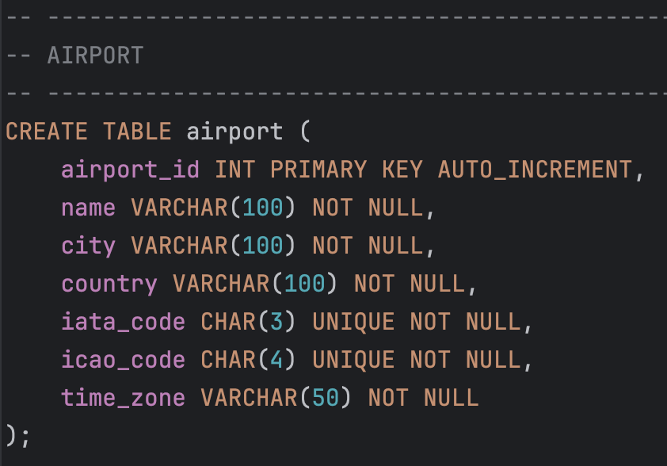

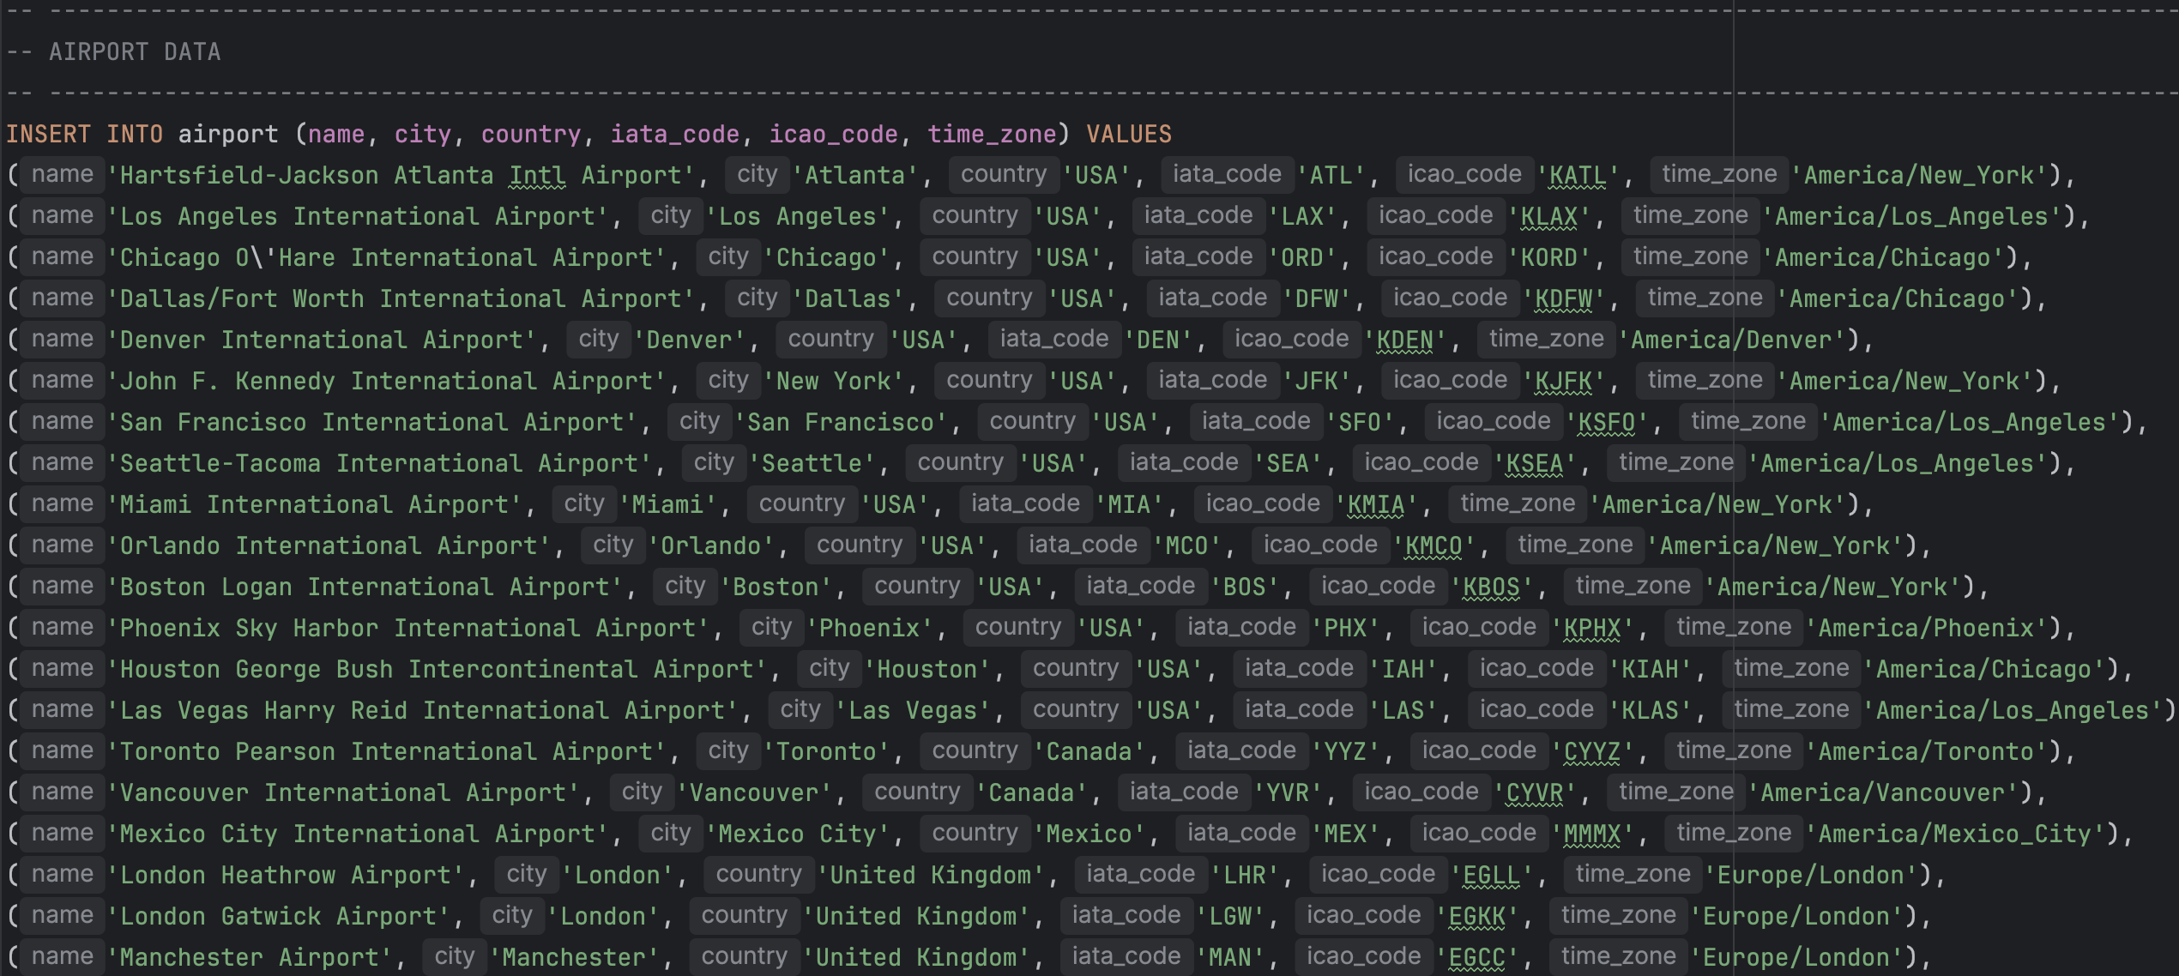

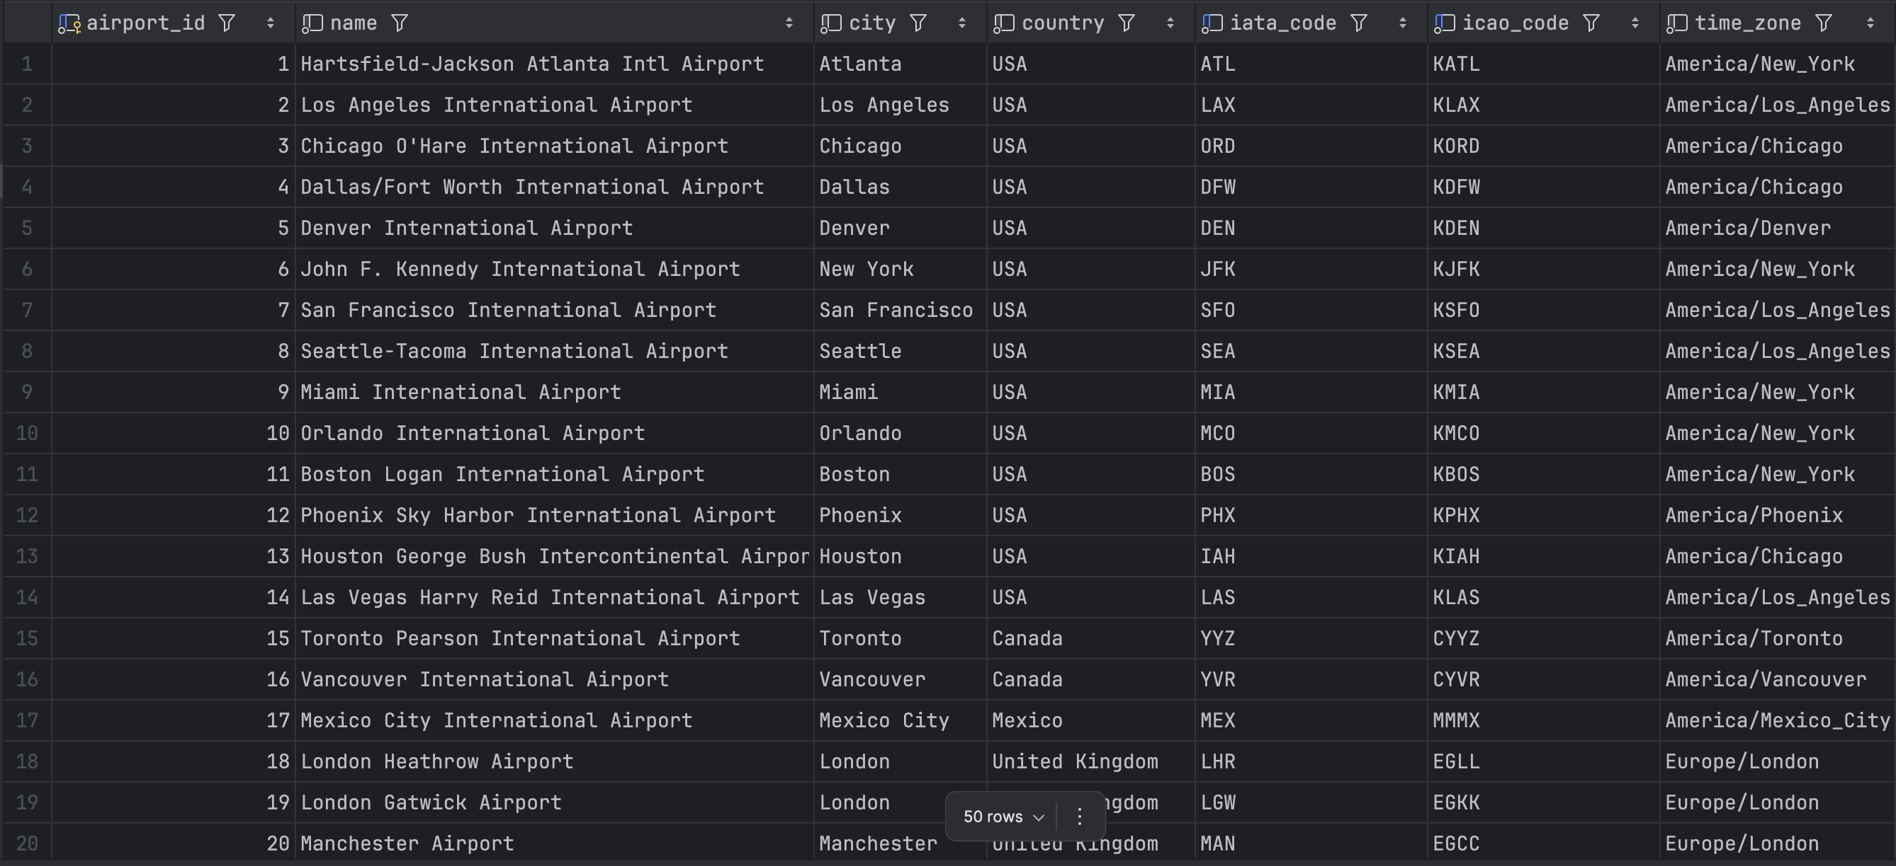

**Airline**

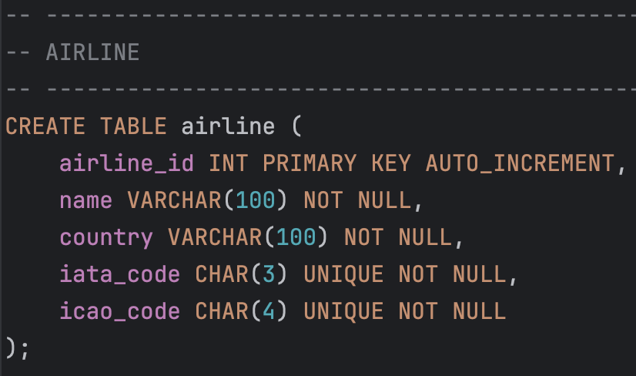

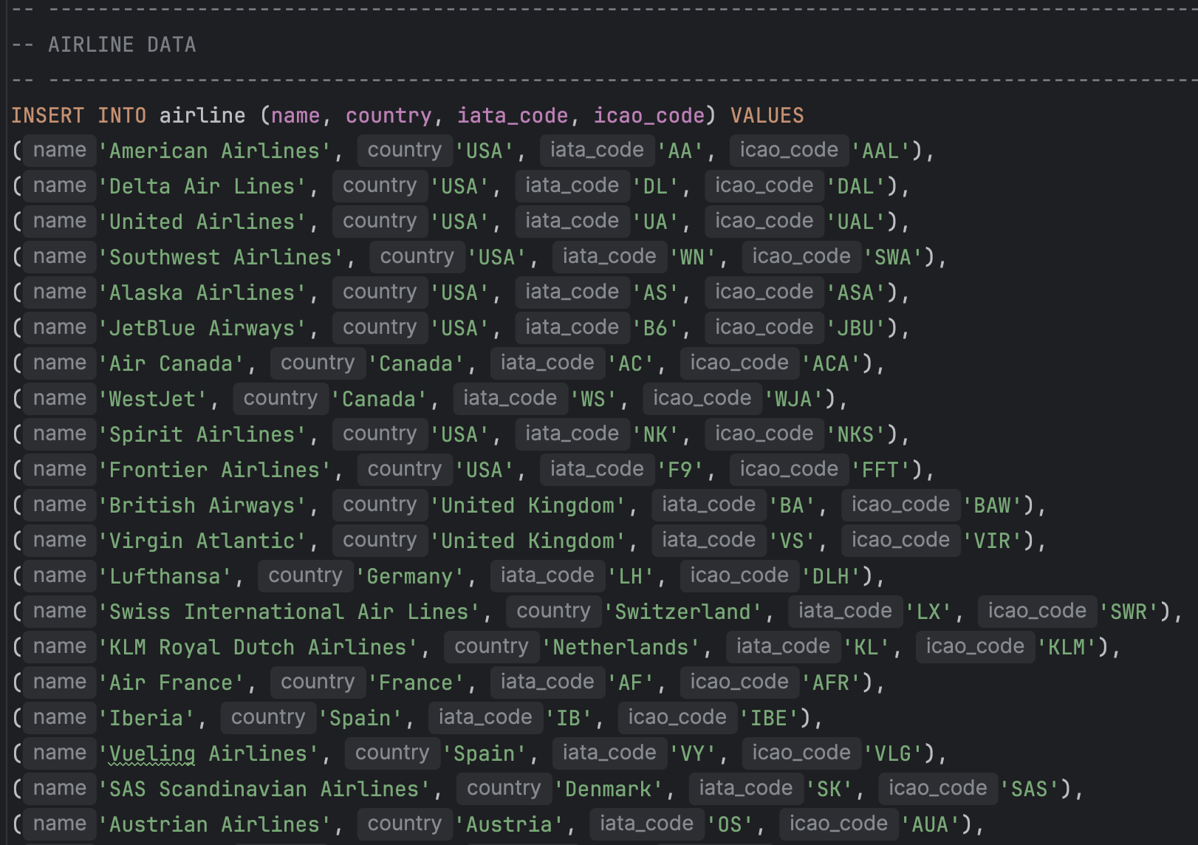

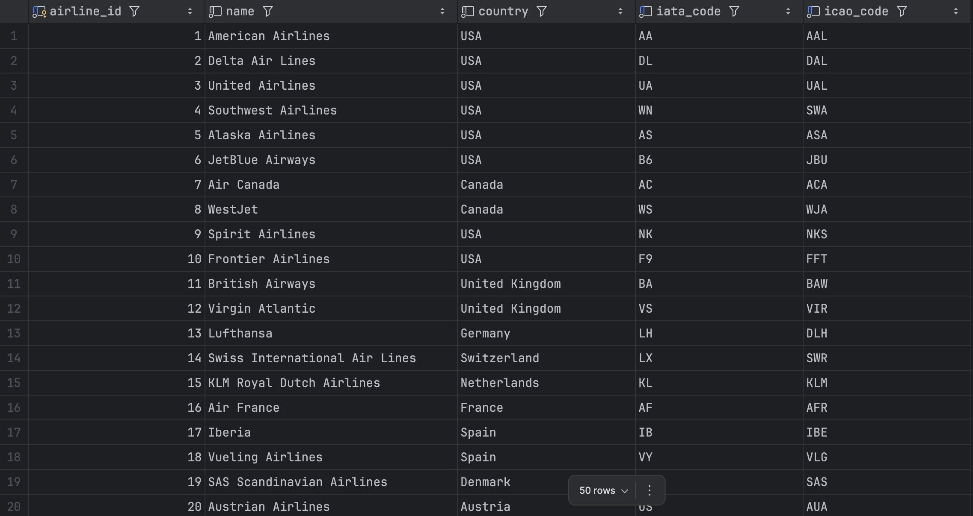

**Aircraft**

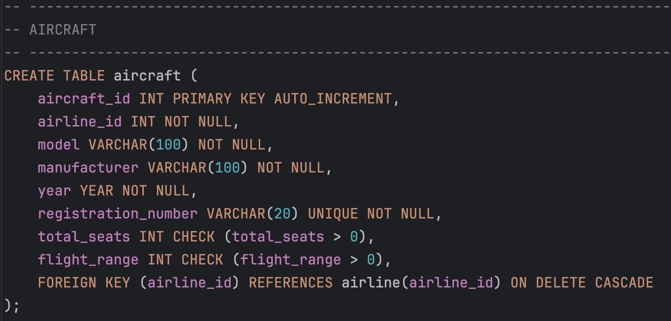

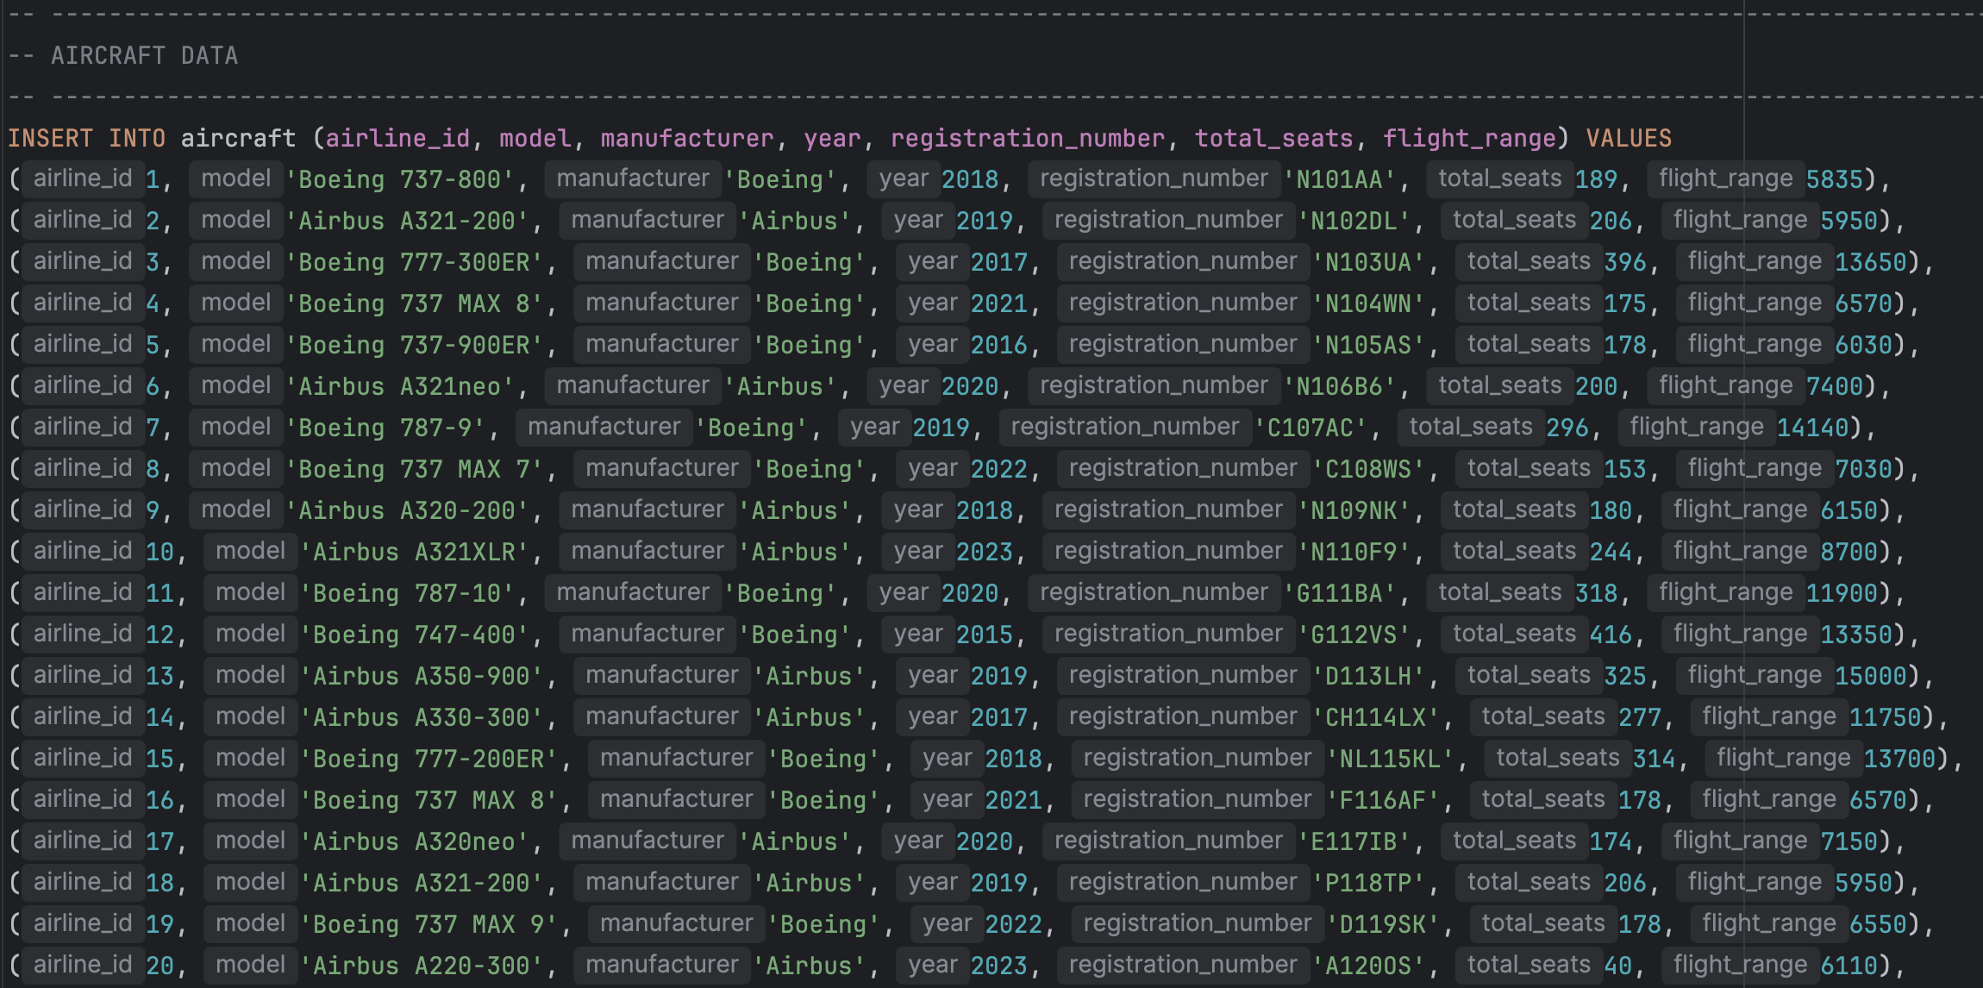

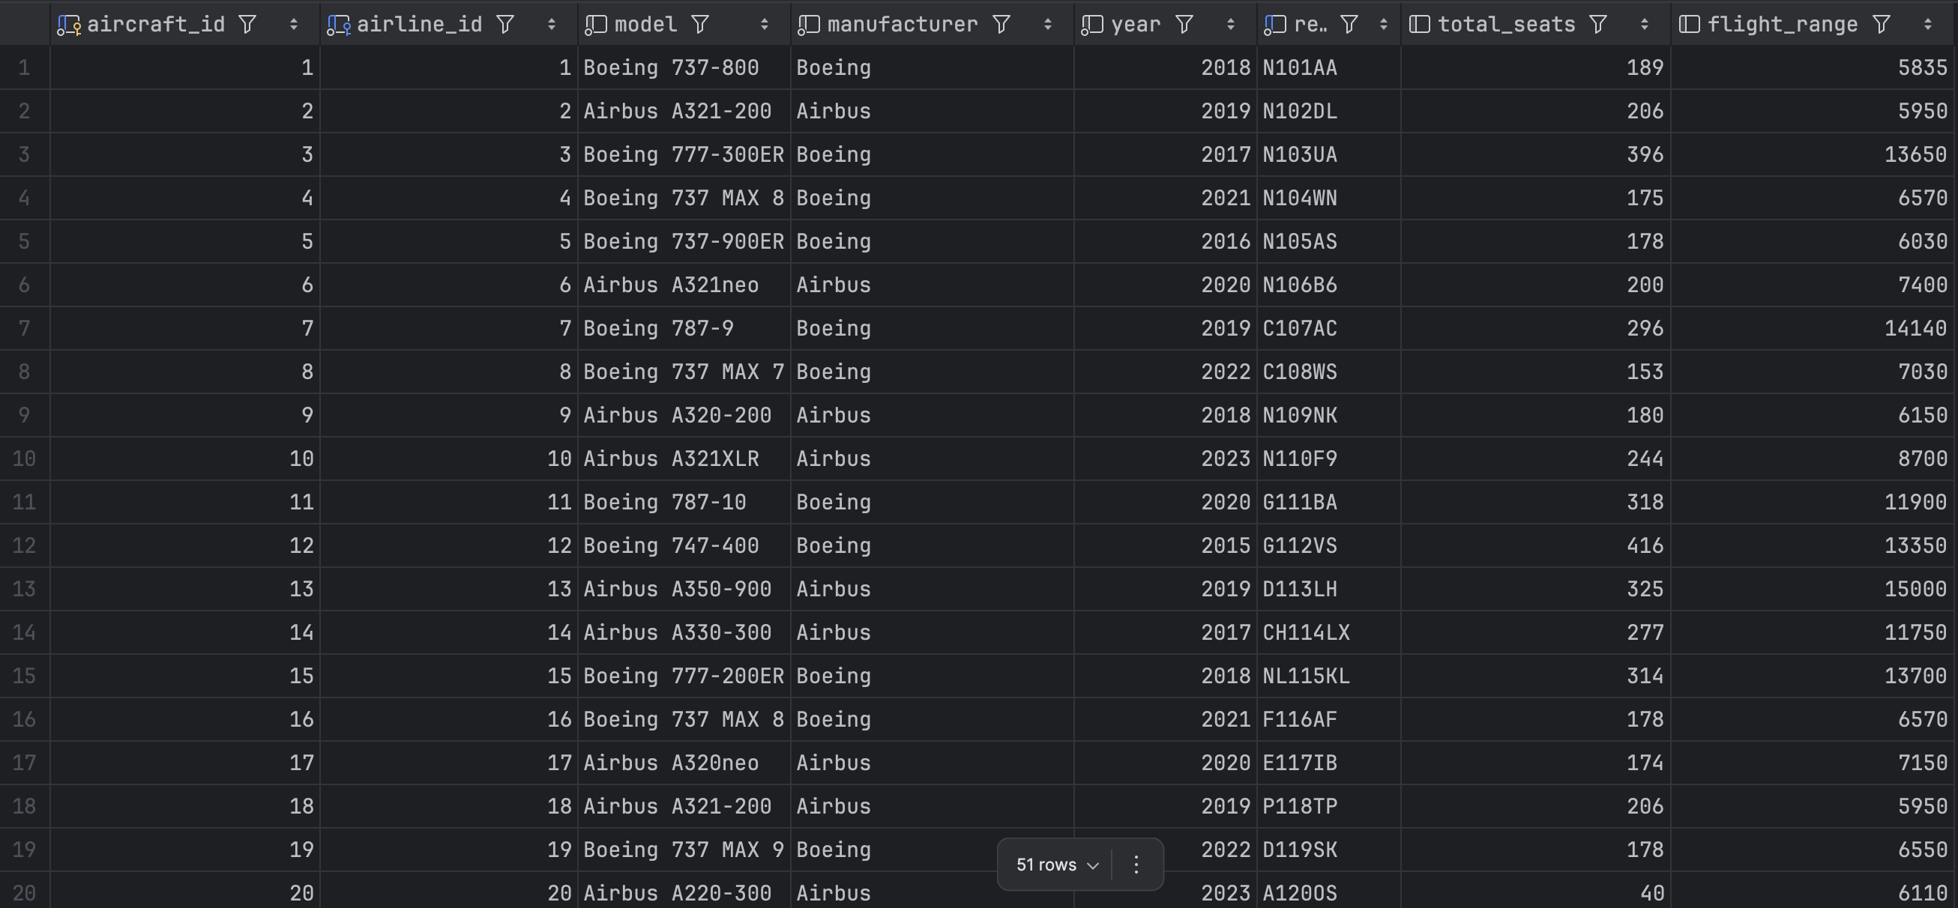

**Flight**

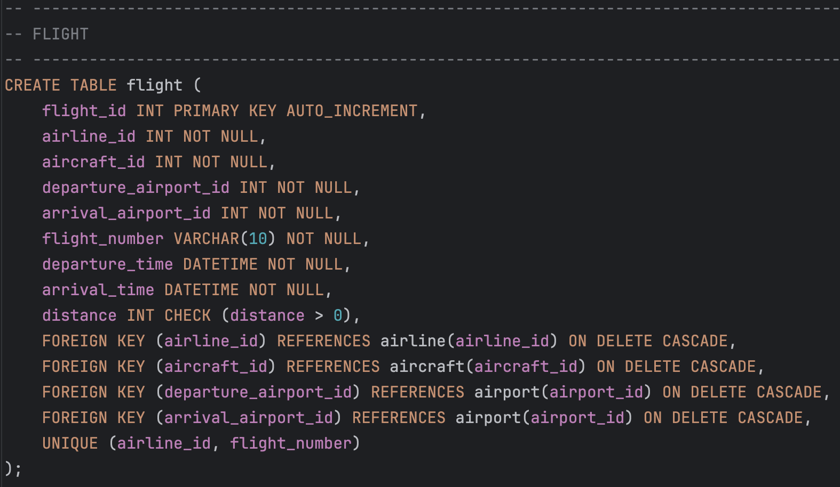

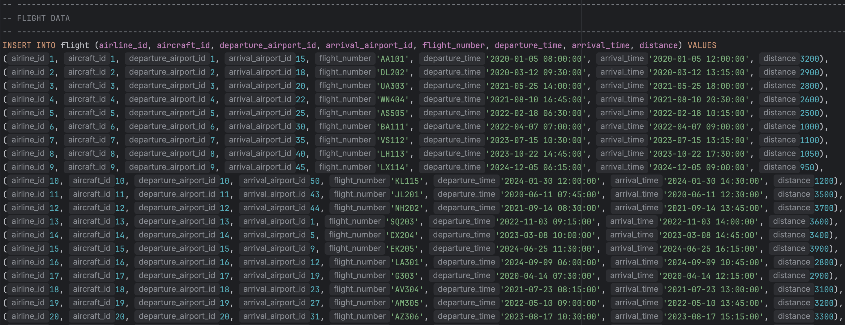

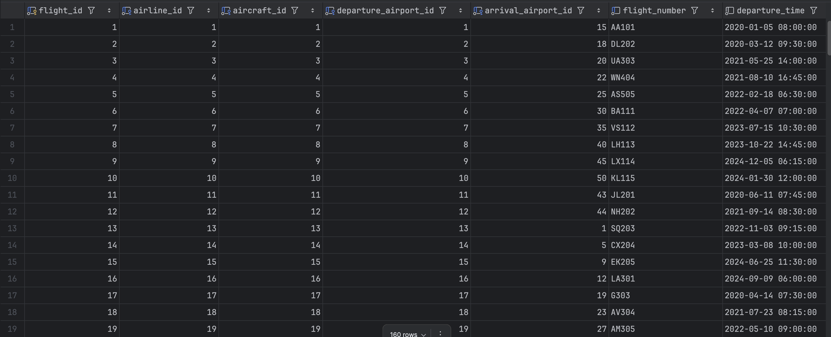

**Passenger**

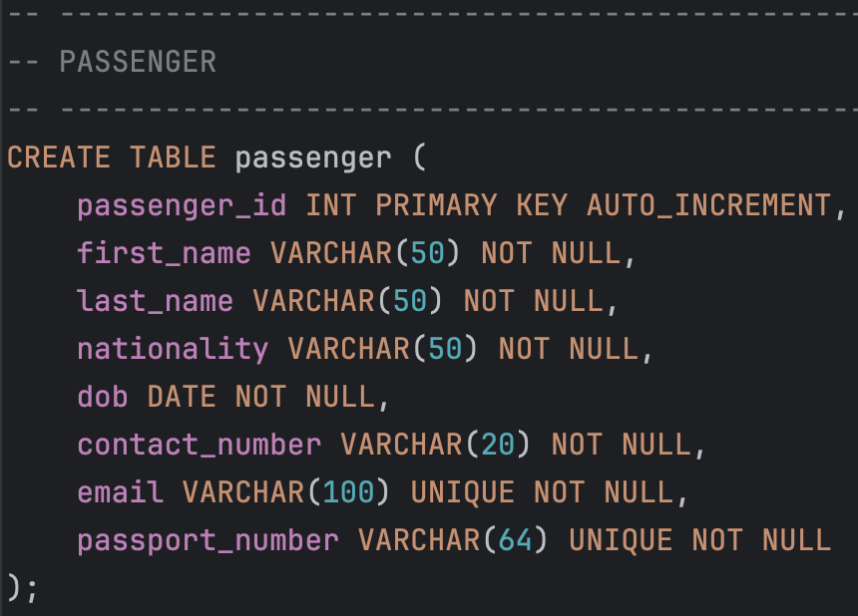

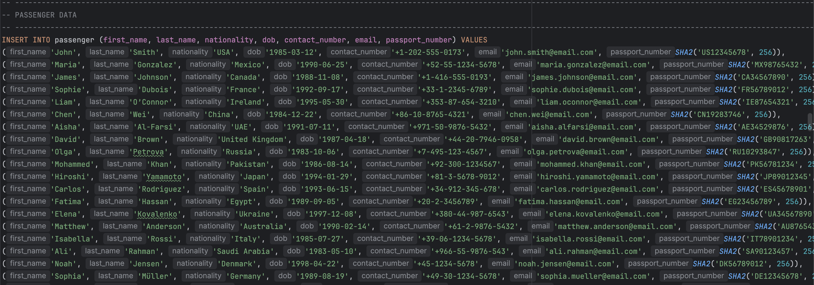

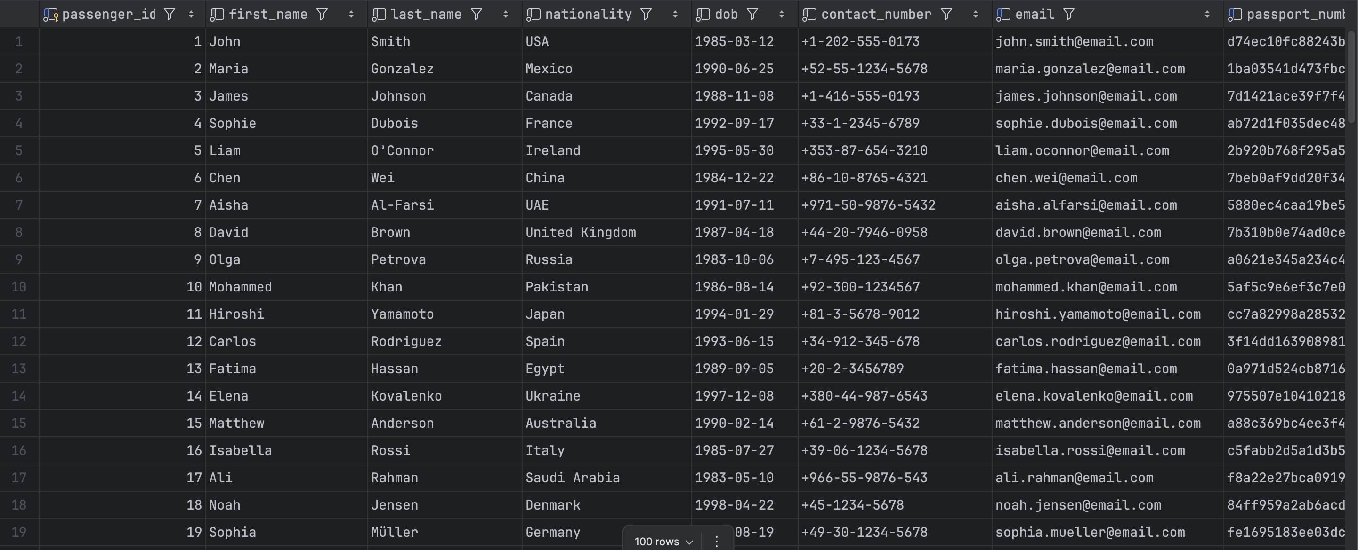

**Ticket**

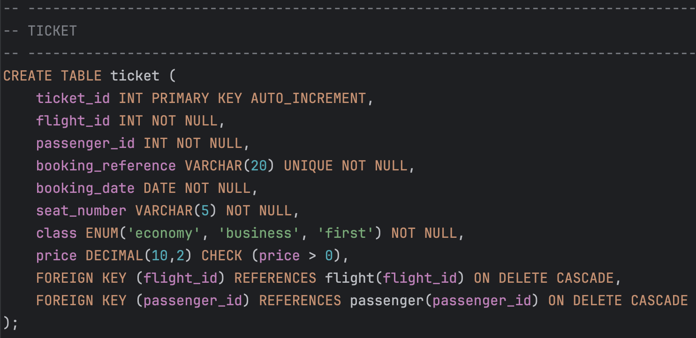

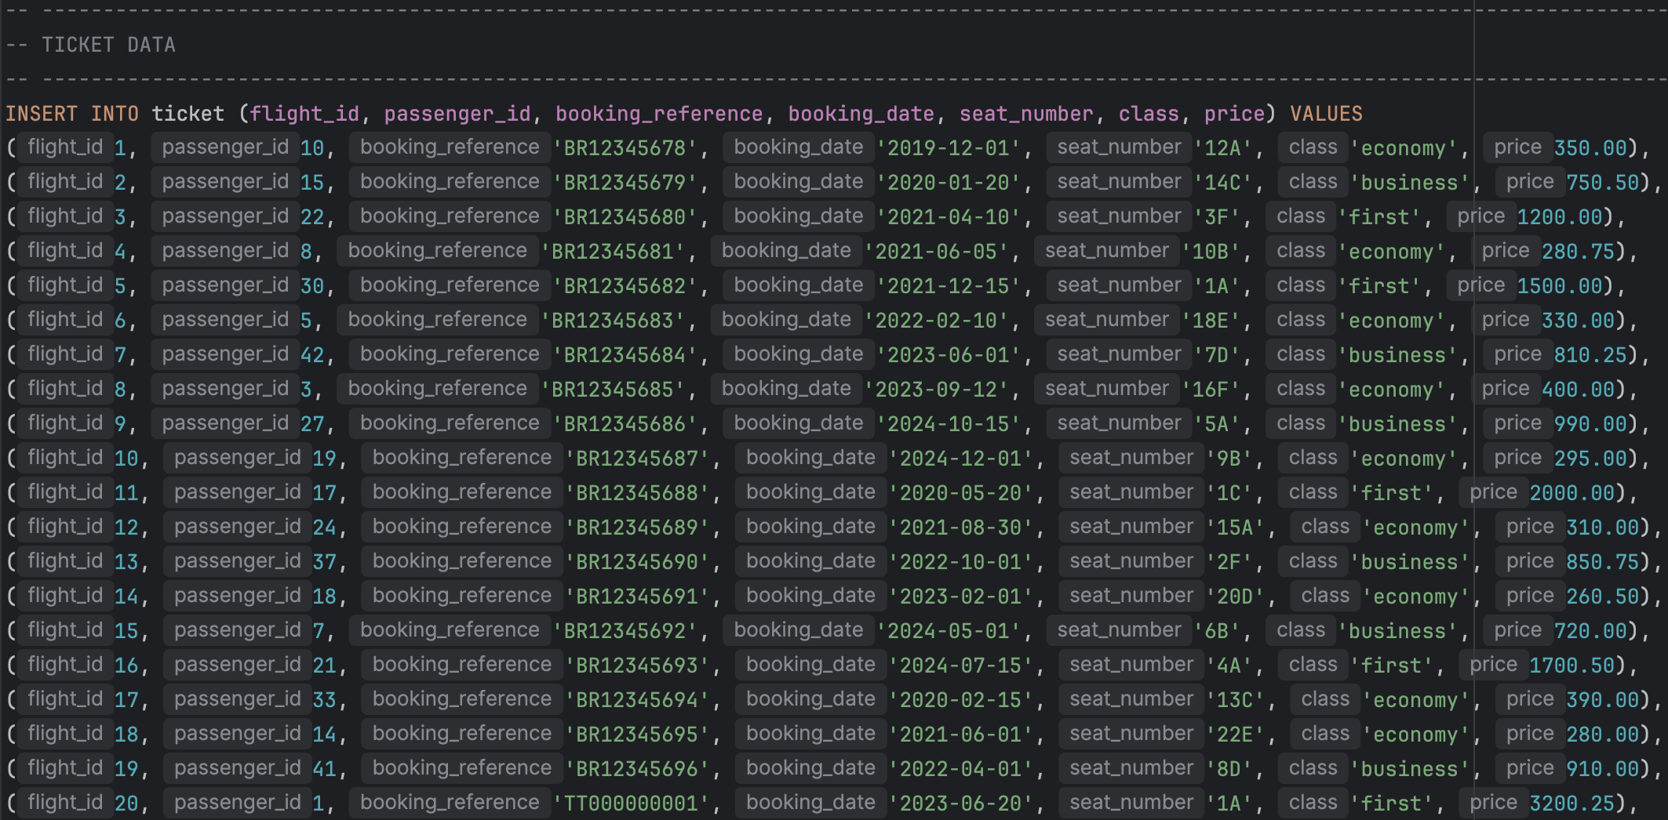

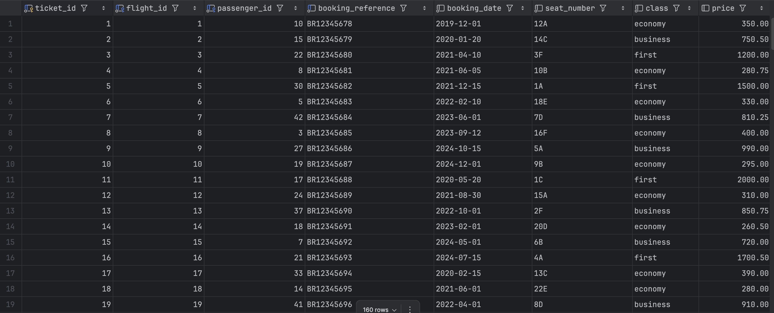

**Baggage**

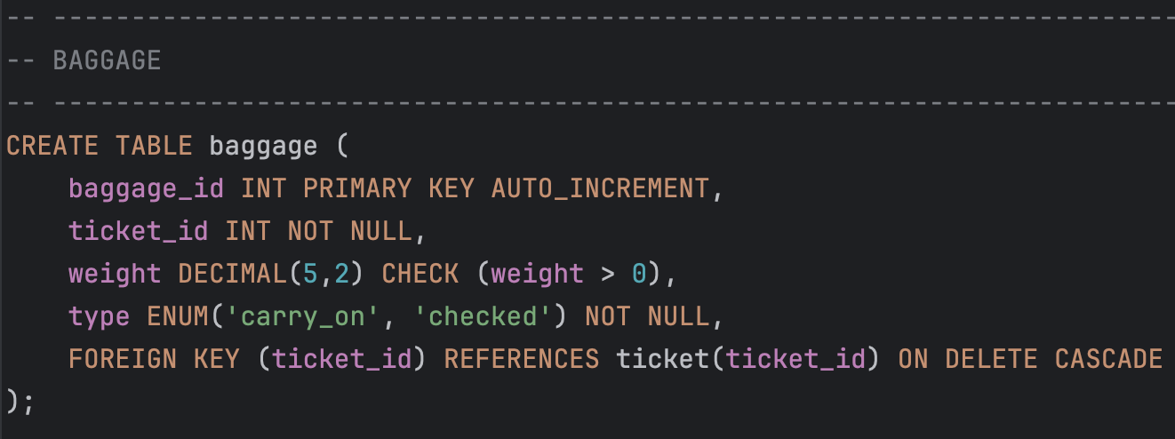

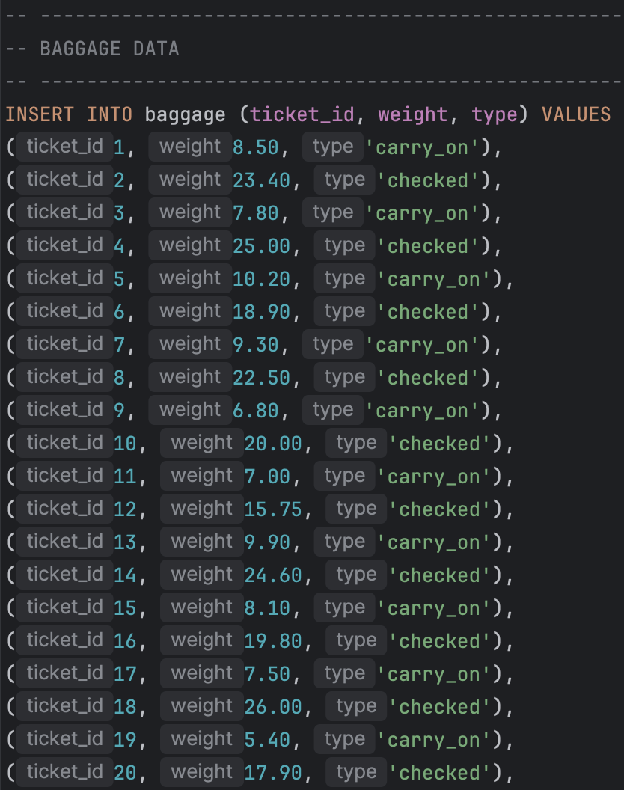

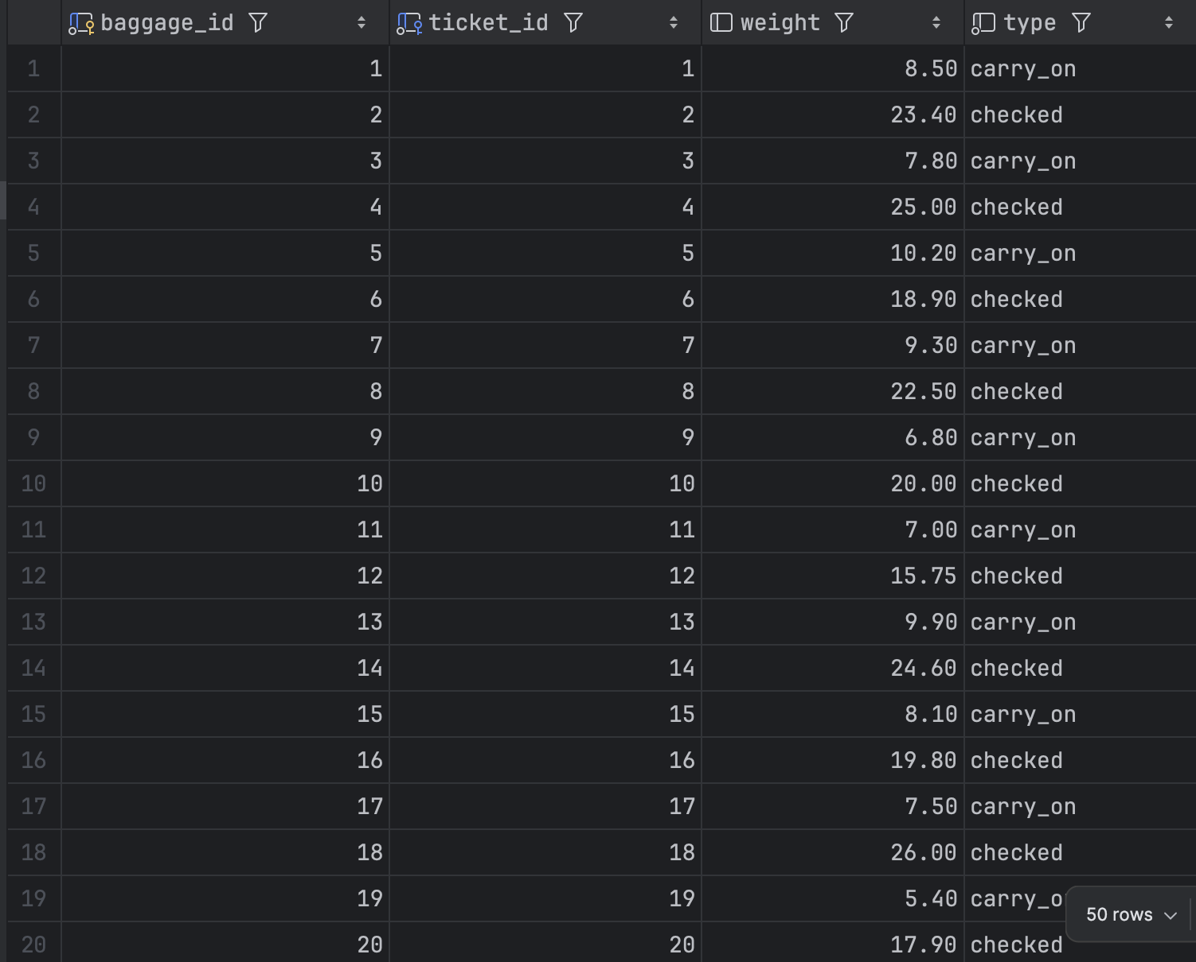

**Payment**

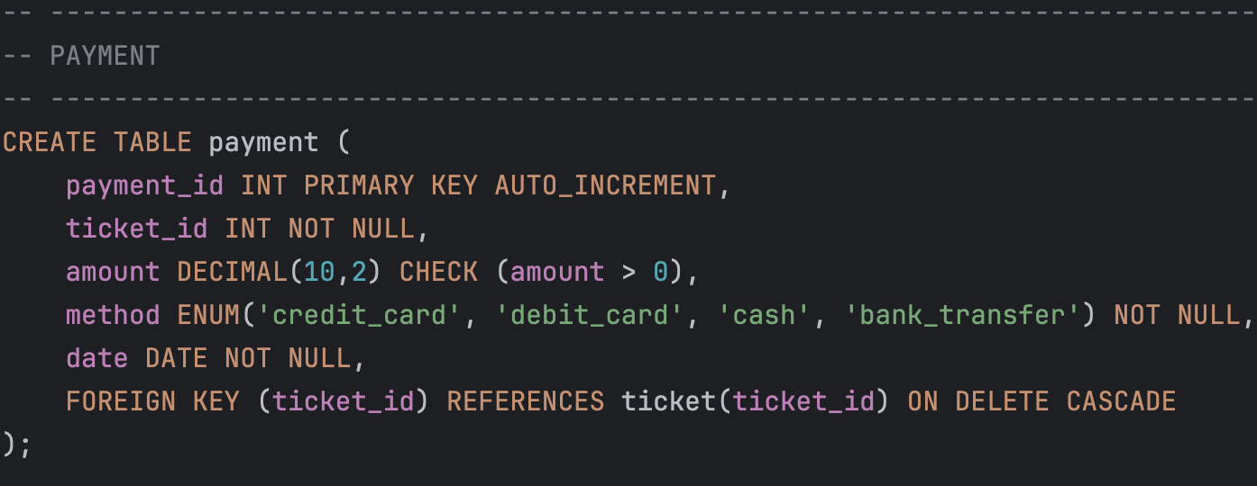

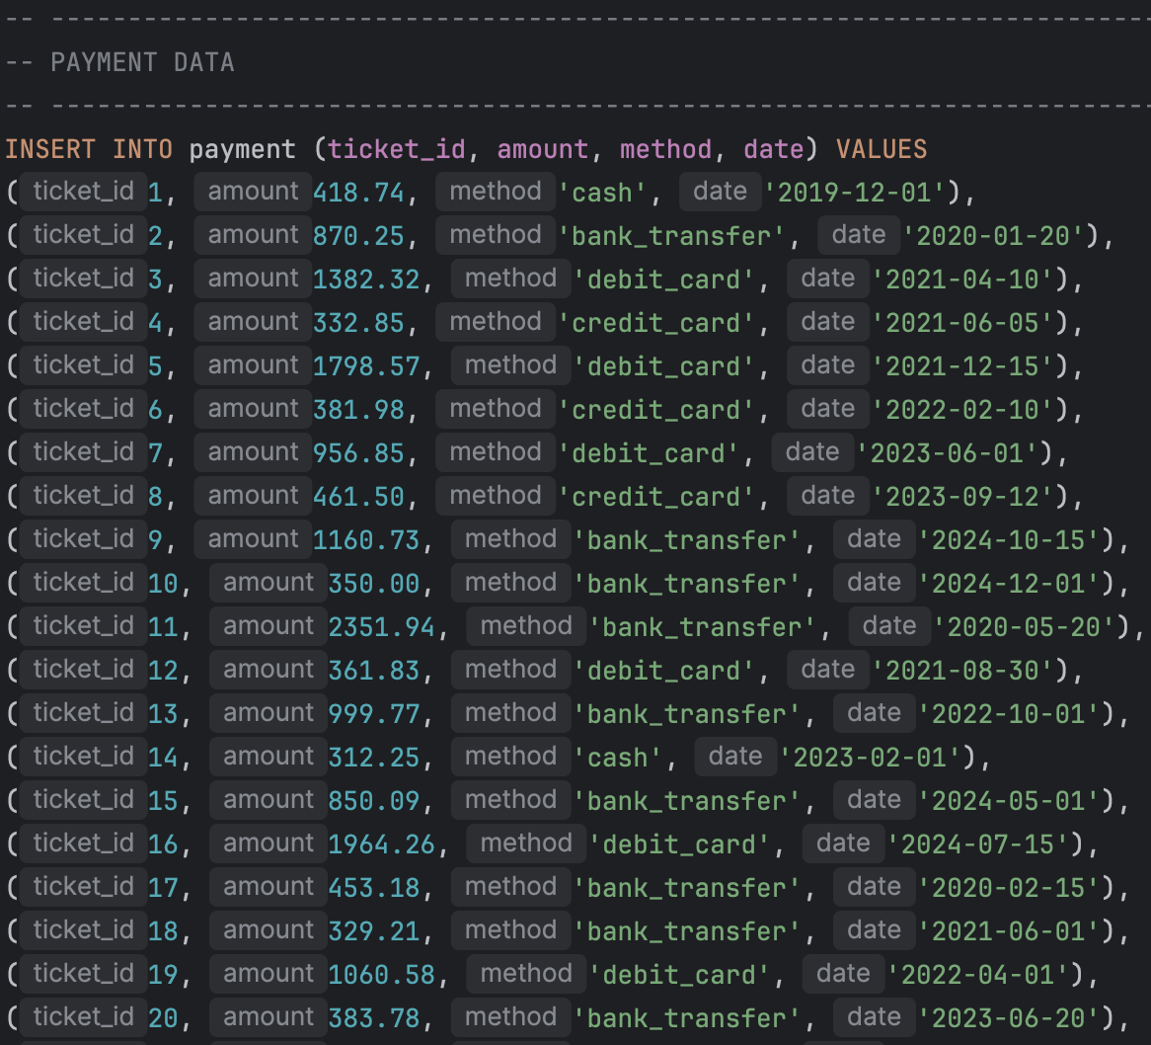

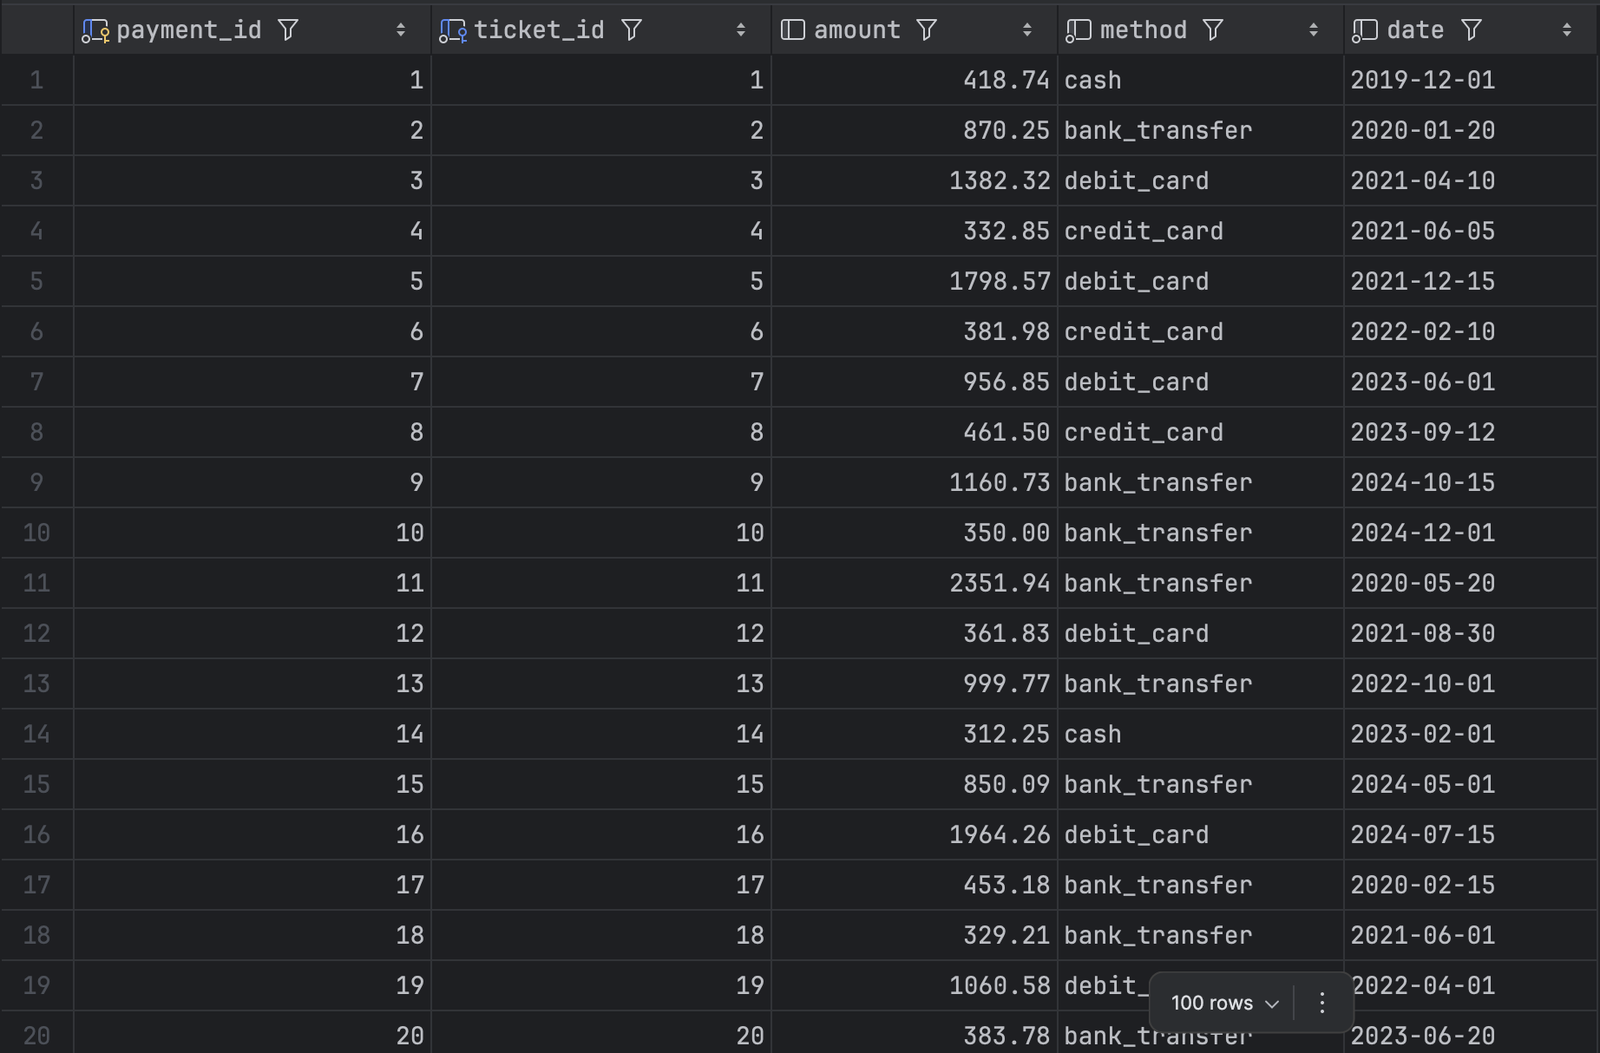

**Crew**

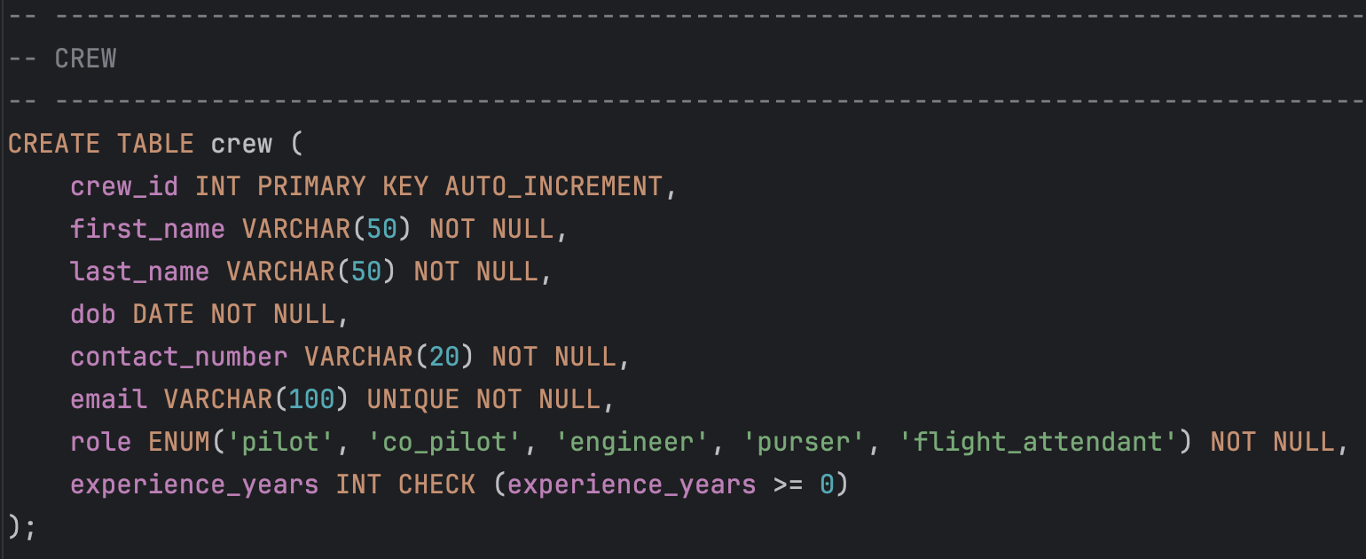

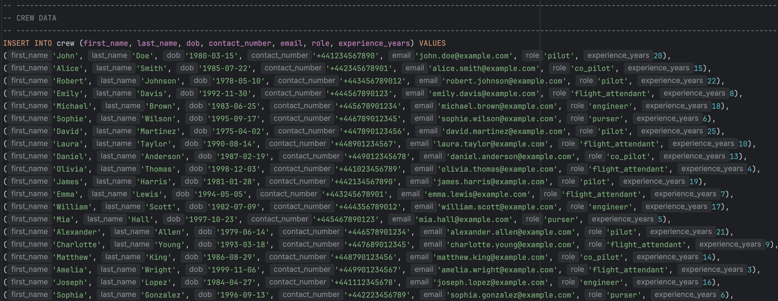

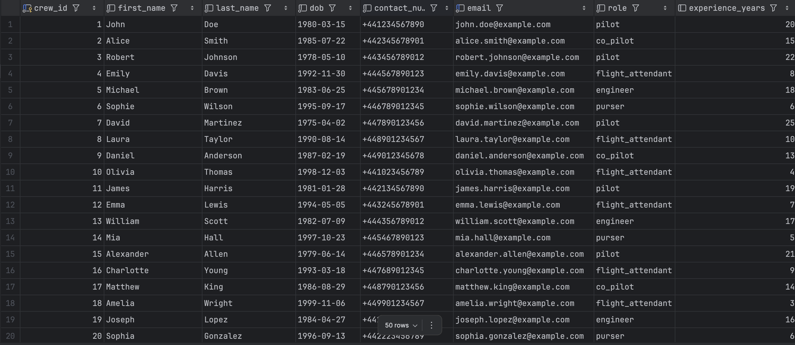

**Flight Crew**

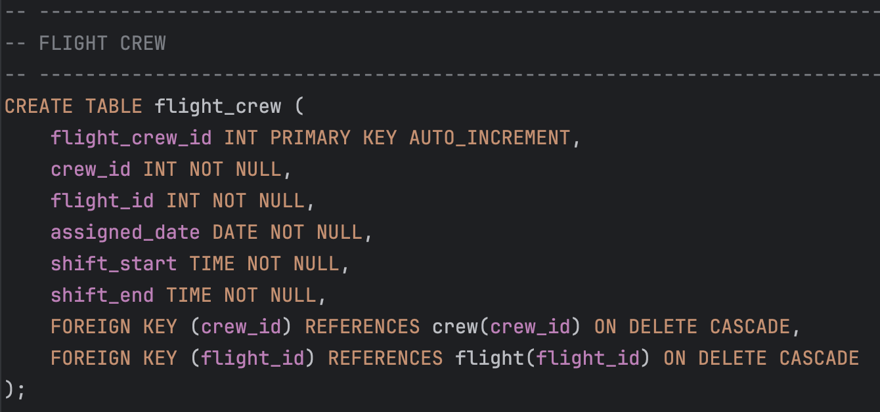

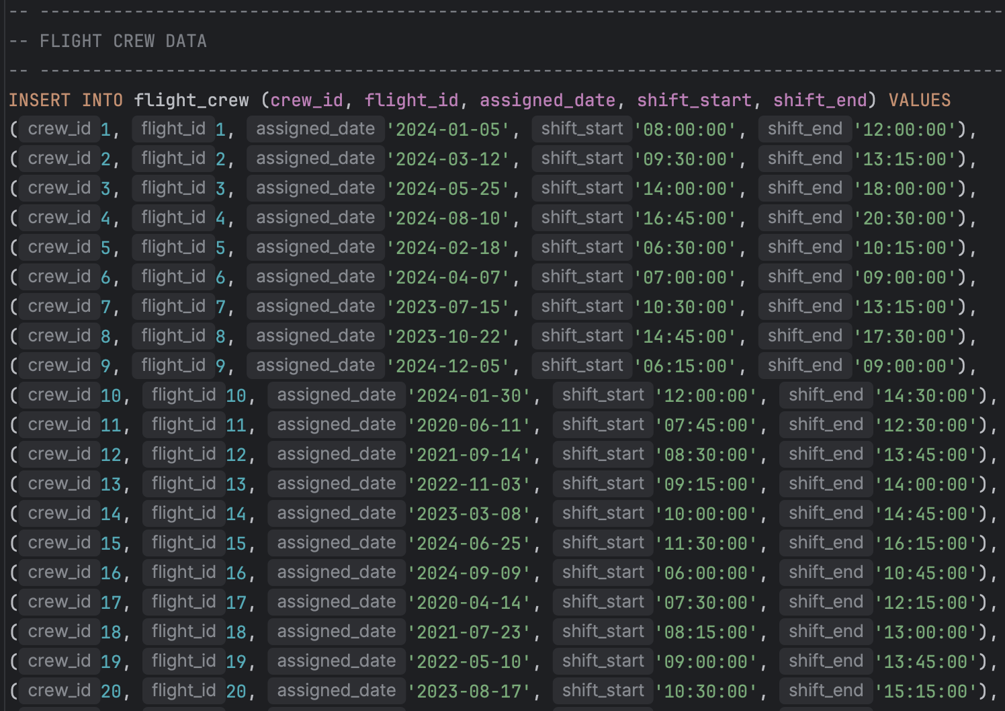

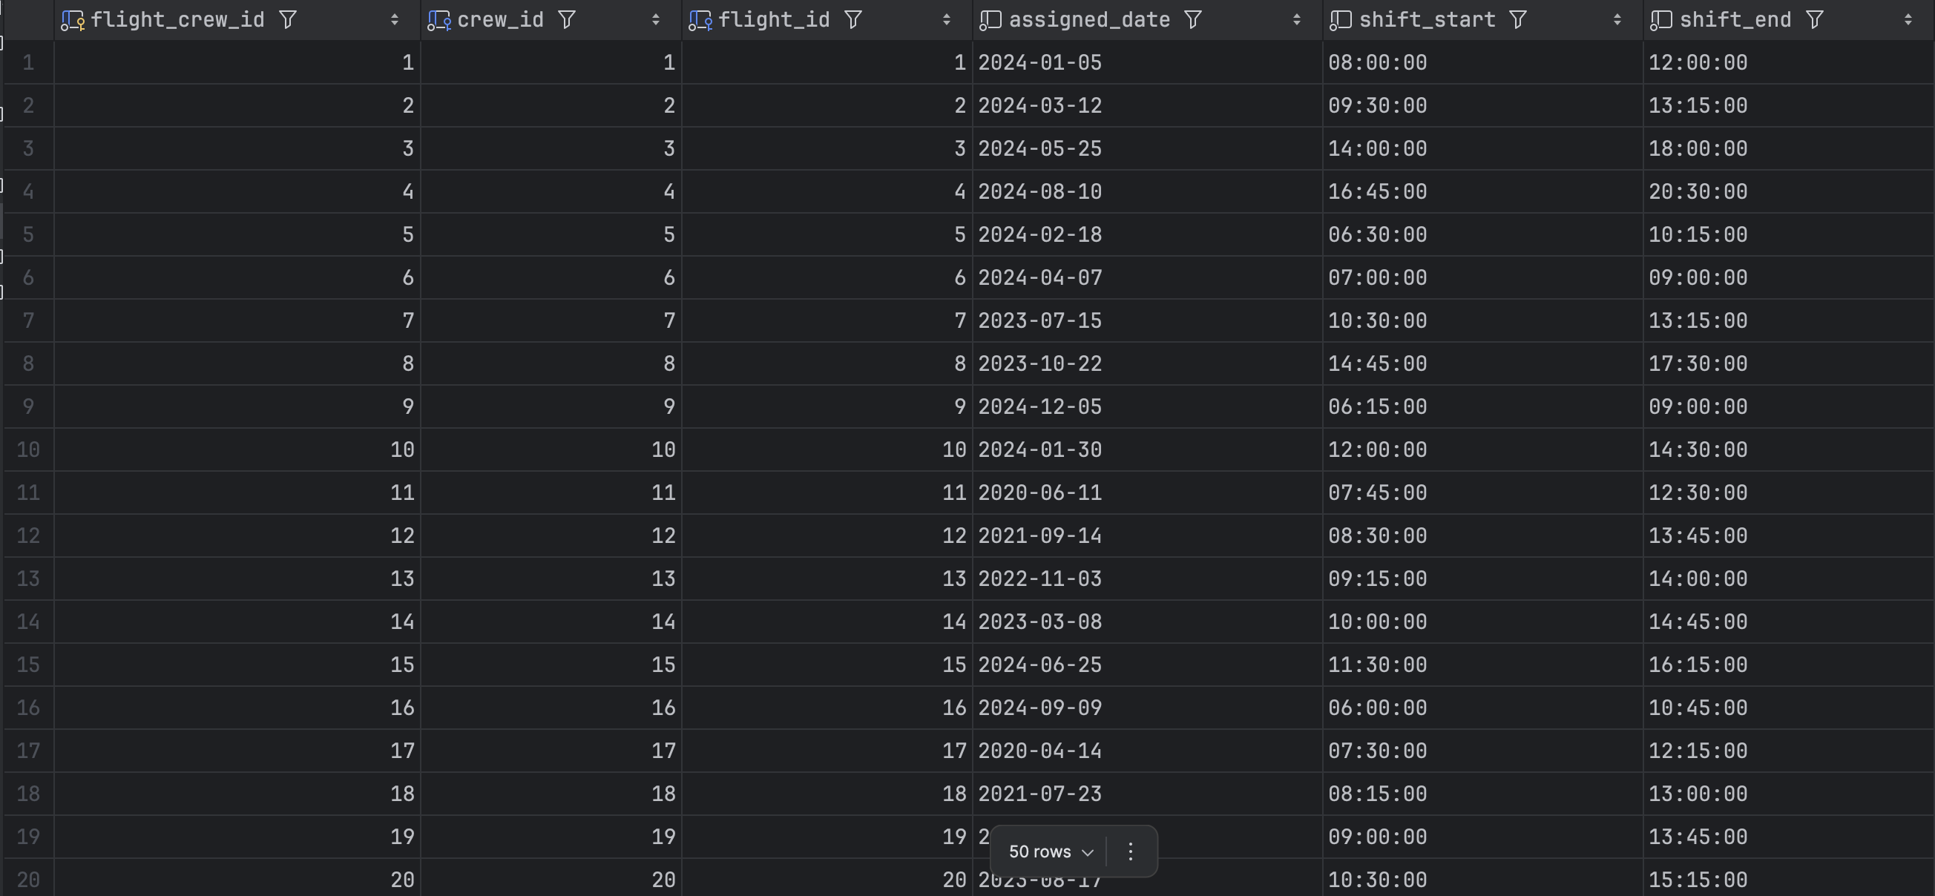

**Delay**

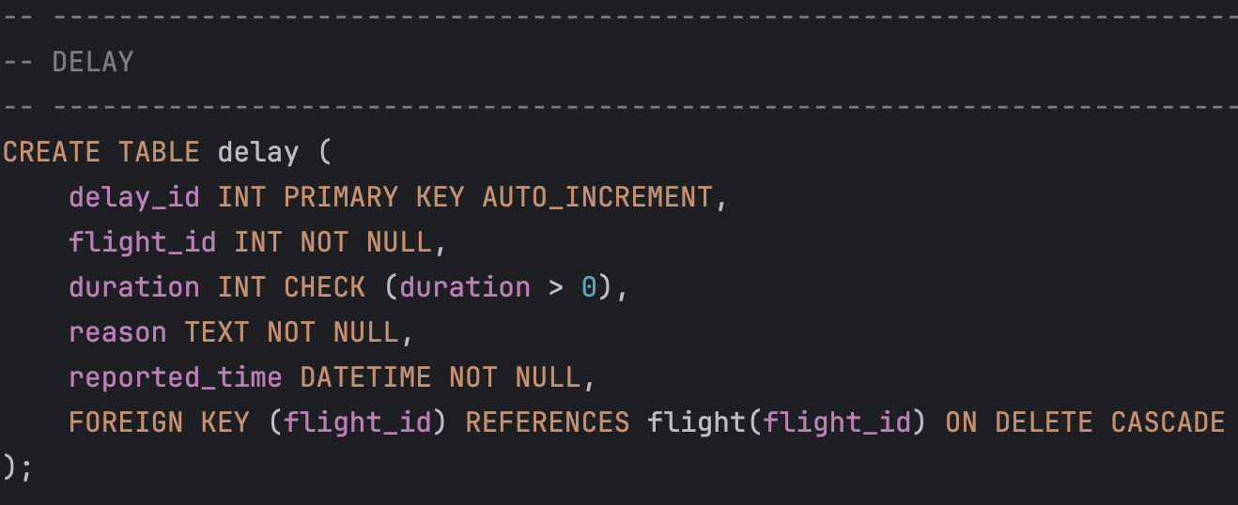

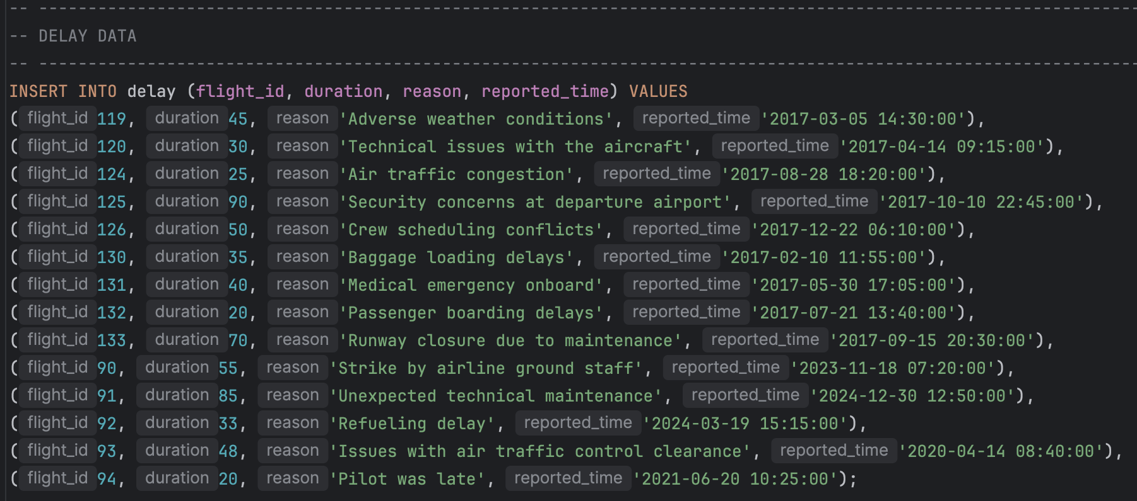

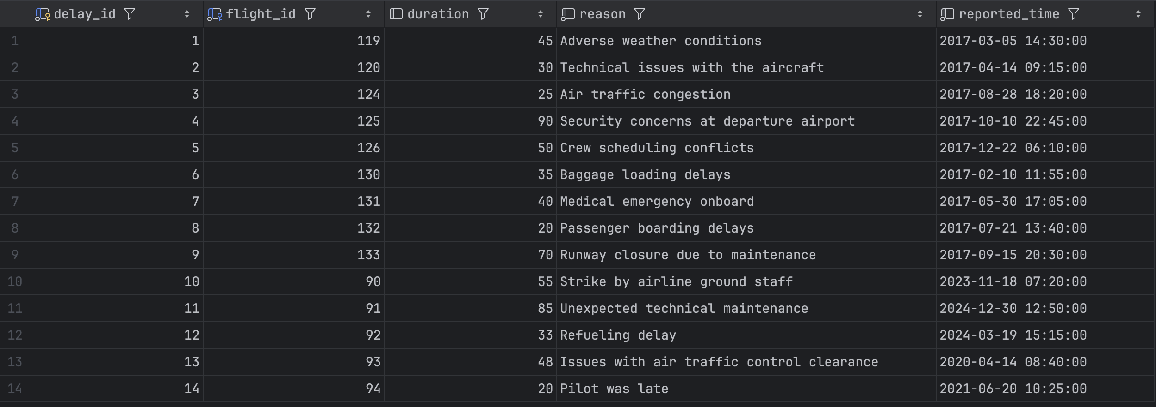

**Cancellation**

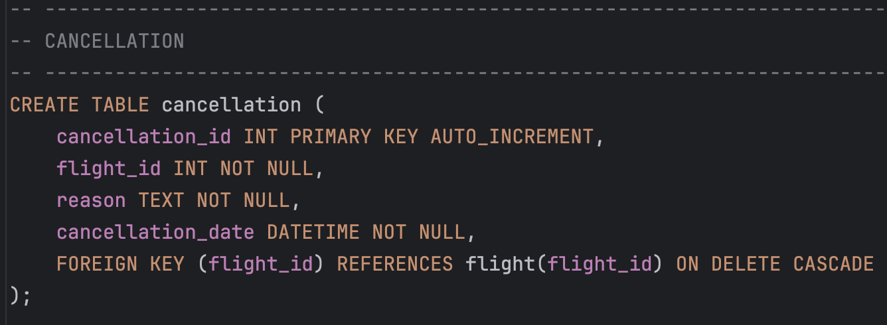

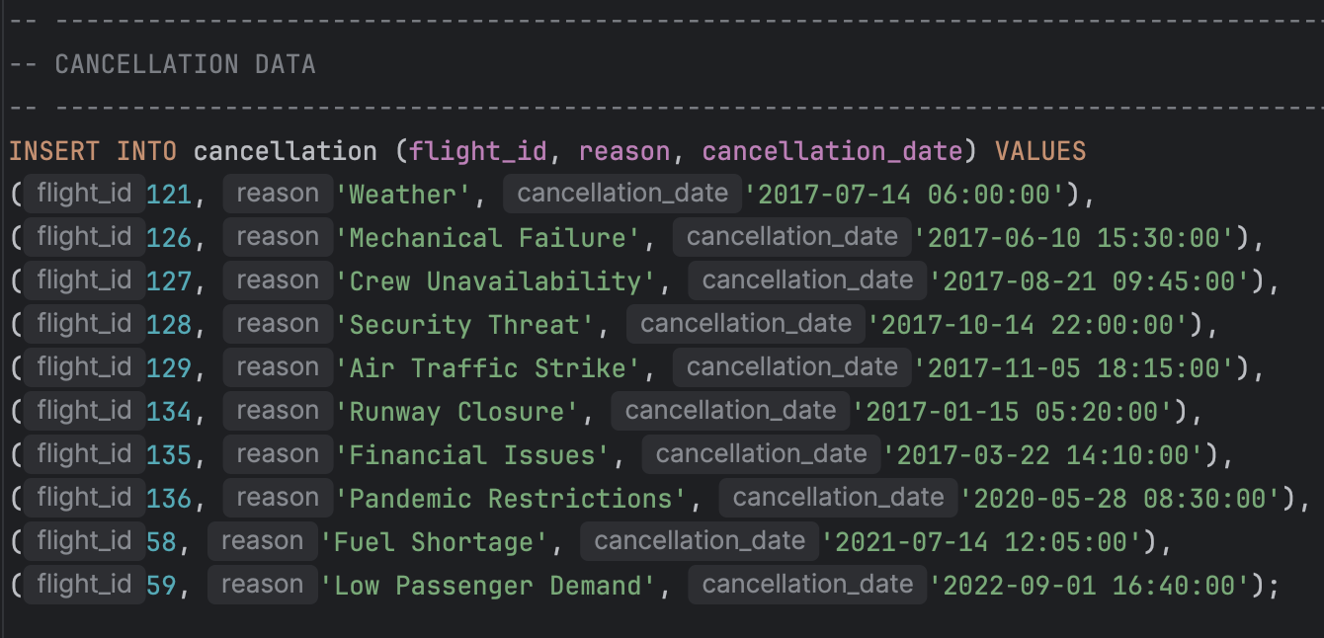

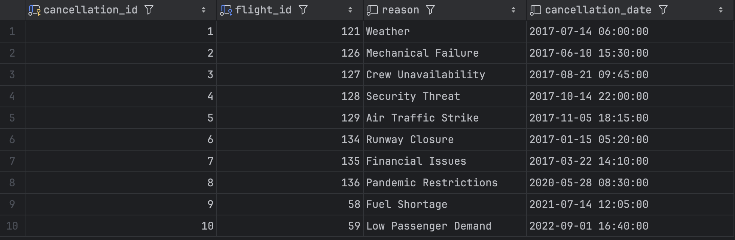

**Log**

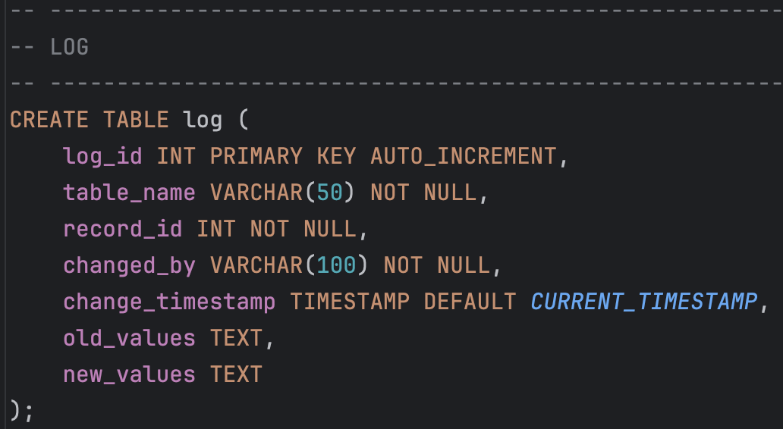

The log table does not contain any pre-inserted data because records will be automatically inserted when triggers are executed.

# **Section 3: Query Design, Construction and Testing**

## **3.1 Query 1**

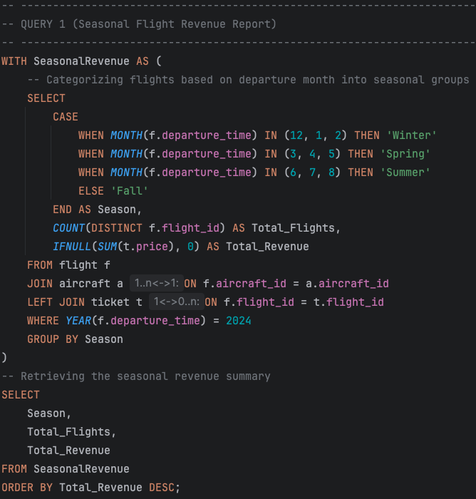

**Business Purpose**

The Seasonal Flight Revenue Report helps airlines analyze revenue trends across different seasons. Understanding which seasons generate the most revenue allows airlines to develop better pricing strategies, advertising plans, and resource allocation.

**SQL Explanation**

Due to the word limit, the explanation for this query is provided in Appendix II (SQL Explanation) instead of the main report.

**Results**

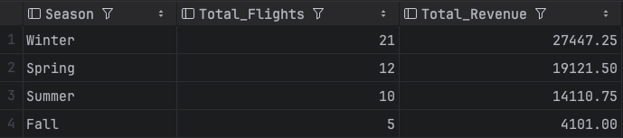

From this screenshot, data analysts can understand that in 2024 the highest revenue season was winter with £27,447.25 (this is not a realistic data, but this query can be applied to a bigger dataset).

## **3.2 Query 2**

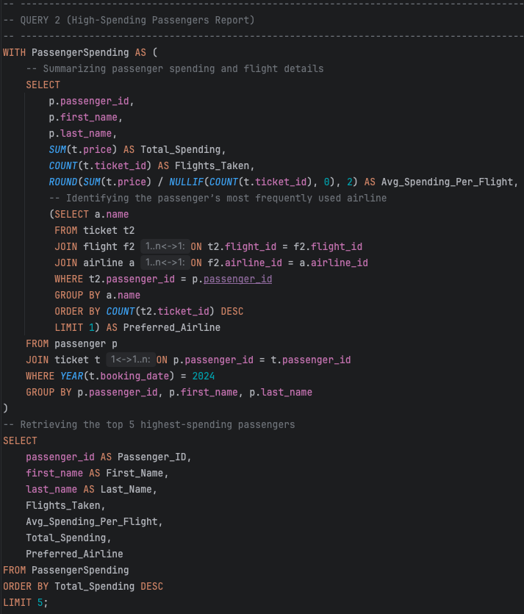

**Business Purpose**

The High-Spending Passengers Report helps airlines identify their highest-spending passengers. Knowing which passengers spend more money and the frequency of flights they take each year helps airlines provide special offers and develop customer services.

**SQL Explanation**

Due to the word limit, the explanation for this query is provided in Appendix II (SQL Explanation) instead of the main report.

**Results**

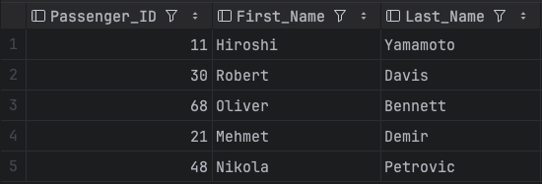

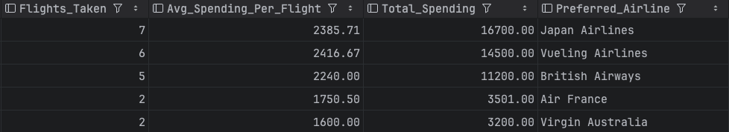

From these screenshots, data analysts can quickly identify the top five highest-spending passengers in 2024. Also, they can see their preferred airline and spending behaviour. This data is crucial for creating targeted marketing strategies to retain profitable customers.

## **3.3 Query 3**

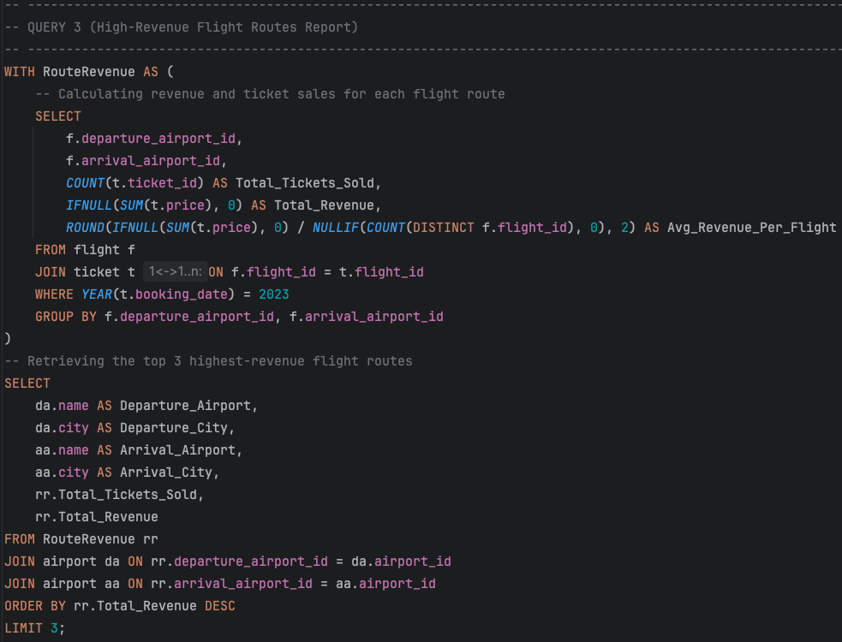

**Business Purpose**

The High-Revenue Flight Routes Report helps data analysts determine the most profitable flight routes by analyzing ticket sales and total revenue for different flight paths. Understanding which routes generate the highest revenue allows airlines to optimize pricing strategies.

**SQL Explanation**

Due to the word limit, the explanation for this query is provided in Appendix II (SQL Explanation) instead of the main report.

**Results**

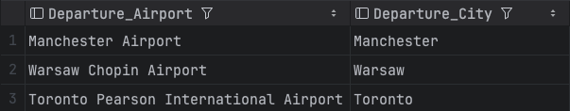

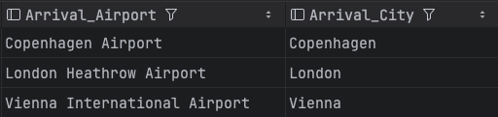

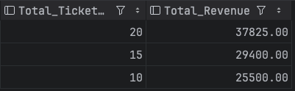

From these screenshots, data analysts can understand that routes such as (Manchester - Copenhagen), (Warsaw - London), (Toronto - Vienna) generated the highest revenue in 2023.

## **3.4 Query 4**

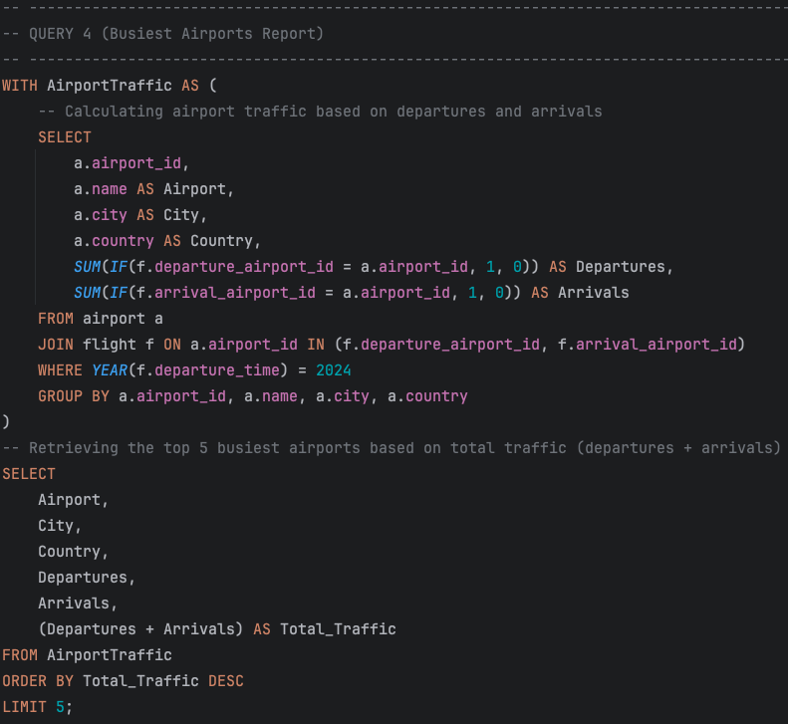

**Business Purpose**

The Busiest Airports Report helps data analysts identify the busiest airports based on total flight traffic, including departures and arrivals. Understanding which airports handle the most flights allows for better resource allocation.

**SQL Explanation**

Due to the word limit, the explanation for this query is provided in Appendix II (SQL Explanation) instead of the main report.

**Results**

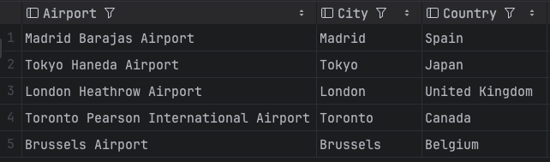

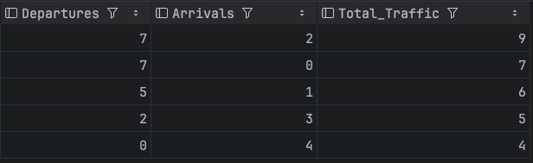

From these screenshots, data analysts can see the top five busiest airports in 2024, ranked by total flight traffic. For example, the busiest airport in this case is Madrid Barajas Airport with 9 total traffic (7 departures + 2 arrivals) (non-realistic data, but still this query can be applied to a bigger dataset).

## **3.5 Query 5**

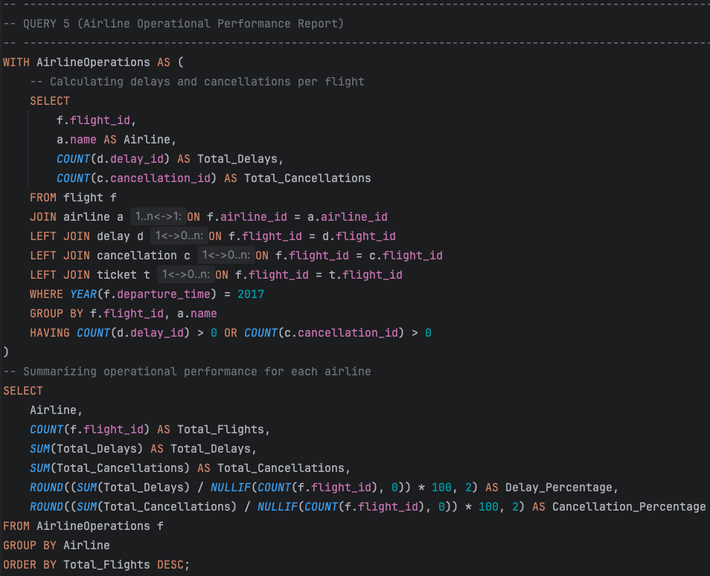

**Business Purpose**

The Airline Operational Performance Report helps data analysts assess airlines operational performance by analyzing delays and cancellations. Understanding how frequently flights are delayed or cancelled allows airline management to identify operational inefficiencies, improve scheduling, and enhance customer satisfaction.

**SQL Explanation**

Due to the word limit, the explanation for this query is provided in Appendix II (SQL Explanation) instead of the main report.

**Results**

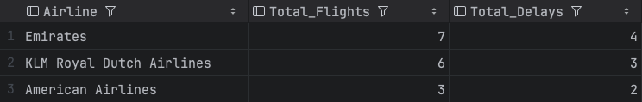

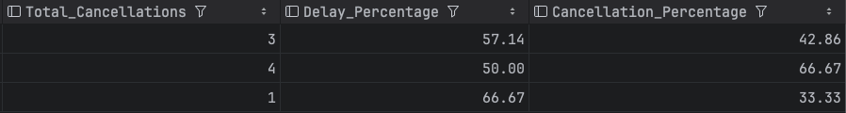  
  
From this screenshot, data analysts can quickly identify which airlines experience the most delays and cancellations. For instance, Emirates Airlines had 7 total flights (100%) in 2017, of which 4 were delayed (57.14%) and 3 were cancelled (42.86%) (not realistic data, as 100% operational issues are unlikely, but this example effectively demonstrates the query). This query can be used as an operational performance test for airlines.

# **Section 4: SQL Programming**

## **4.1 Procedure 1**

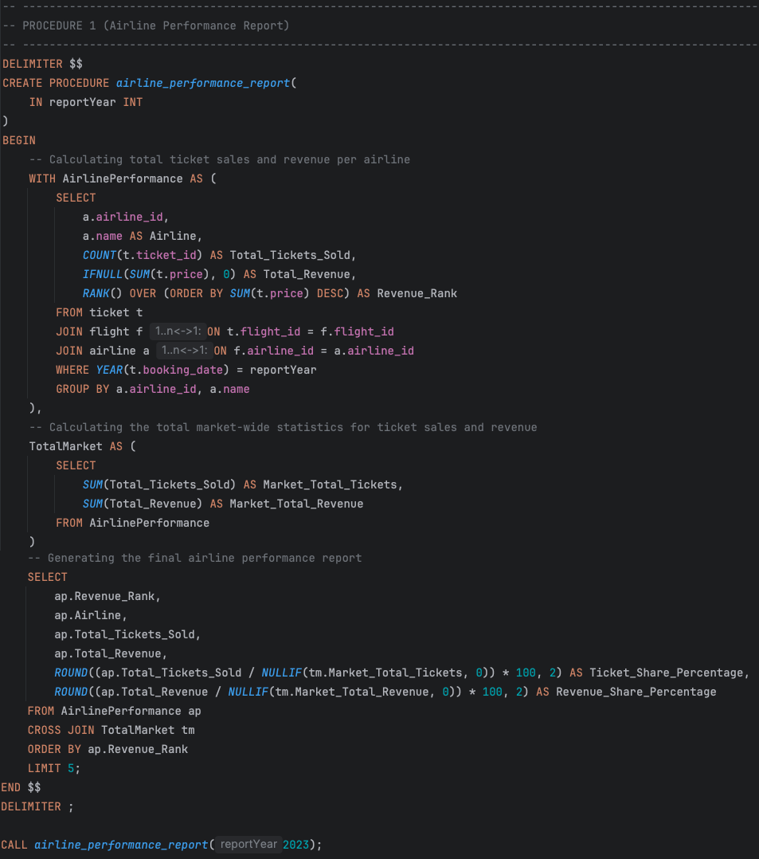

**Business Purpose**

The Airline Performance Report displays how different airlines perform in terms of ticket sales and revenue. By ranking airlines based on total revenue and calculating their market share, this report helps airline managers, investors, and analysts understand competitive positioning.

**SQL Explanation**

Due to the word limit, the explanation for this procedure is provided in Appendix II (SQL Explanation) instead of the main report.

**Results**

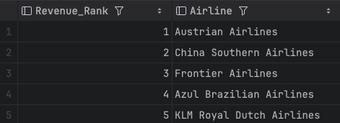

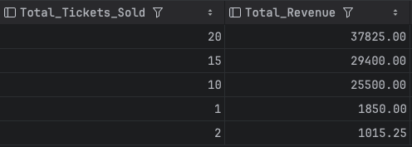

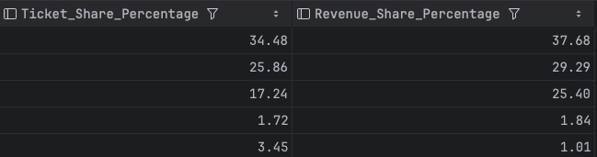

From these screenshots, data analysts can see the top five performing airlines in 2023 by revenue and examine their market share via ticket sales and revenue. As an example, Austrian Airlines ranked first as the top-performing airline in 2023. It sold 20 tickets, generating a total revenue of £37,825 (non-realistic result, but good example). This airline accounted for 34.48% of all ticket sales and 37.68% of the total revenue share.

## **4.2 Procedure 2**

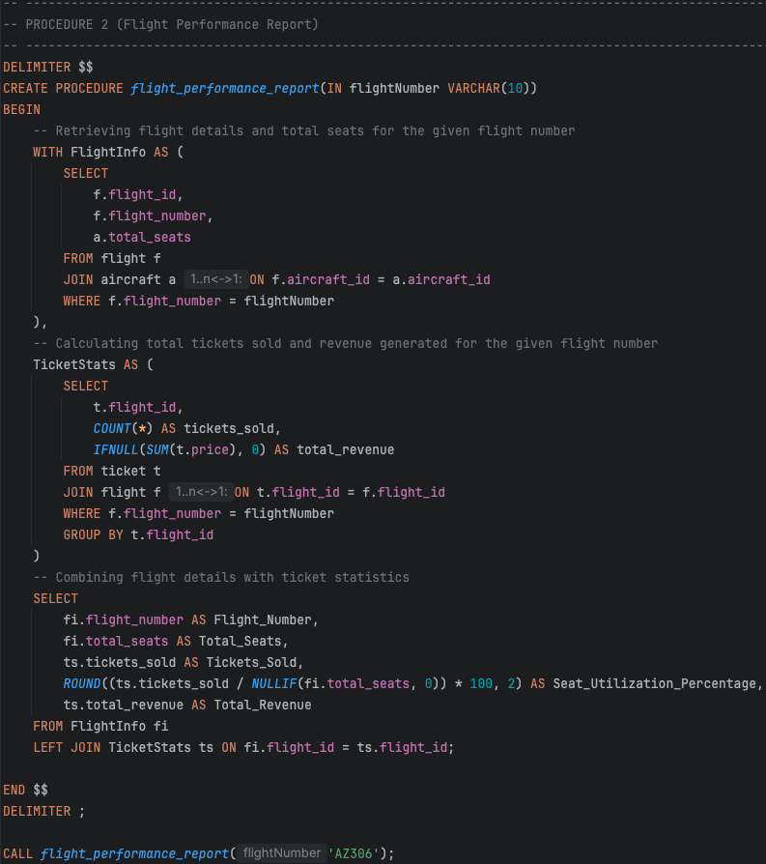

**Business Purpose**

The Flight Performance Report helps airlines analyze the occupancy and revenue generated by a specific flight. With the help of this procedure, analysts can see how many tickets were sold compared to available seats and airlines can assess seat utilization efficiency.

**SQL Explanation**

Due to the word limit, the explanation for this procedure is provided in Appendix II (SQL Explanation) instead of the main report.

**Results**





From these screenshots, airline managers can analyze the seat utilization and revenue of a given flight. For example, these results show that the flight with number “AZ306” (which was entered as an argument in the procedure) has a total of 40 seats (this is a specific aircraft, it was intentionally assigned only 40 seats to it in the data.sql file). Only 20 tickets were sold on this flight, which means that only half of the aircraft was occupied (50% seat utilization).

## **4.3 Procedure 3**

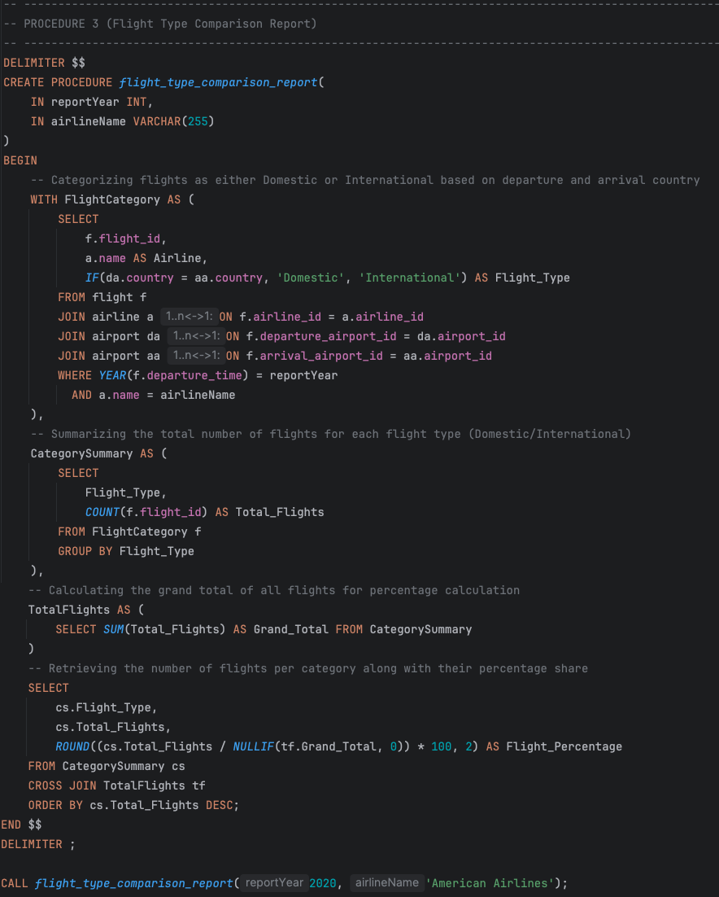

**Business Purpose**

The Flight Type Comparison Report helps airlines analyze their flight distribution between domestic and international routes. Knowing the difference between flight types allows airlines to adjust their strategies for market expansion and route planning.

**SQL Explanation**

Due to the word limit, the explanation for this procedure is provided in Appendix II (SQL Explanation) instead of the main report.

**Results**

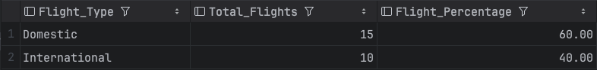

From these results, airlines can see how their flight operations are distributed between domestic and international flights for a given year. For instance, in 2020, American Airlines had 15 domestic flights and 10 international flights (unrealistic data, but good as an example), meaning that 60% of their total flights were domestic. Which means that American Airlines should focus more on domestic flight operations.

## **4.4 Trigger 1**

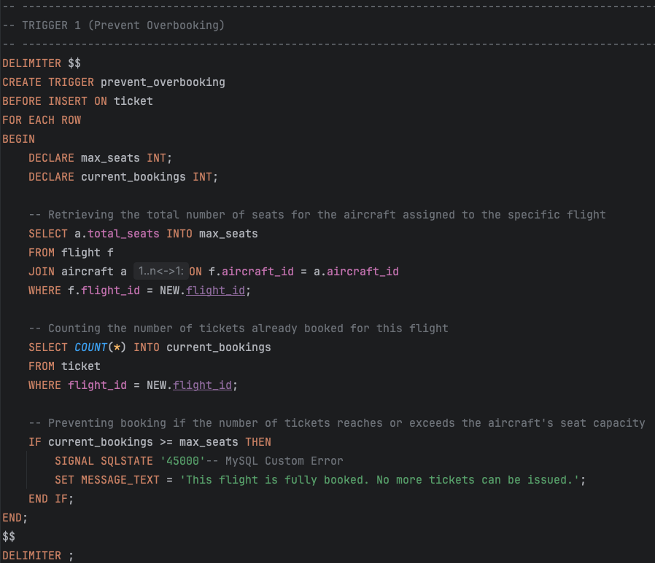

**Explanation**

Due to the word limit, the explanation for this trigger is provided in Appendix II (SQL Explanation) instead of the main report.

**Testing**To test this, the "Flight Performance Report" procedure is used to identify the total number of seats and tickets that have already been sold for the flight with the number "XX000".

  
  
The result shows that the total number of seats in the "XX000" flight's aircraft is 1 (the aircraft was intentionally assigned with only one seat and assigned it to this flight). It also shows that the number of tickets sold is NULL, meaning no tickets have been purchased yet.



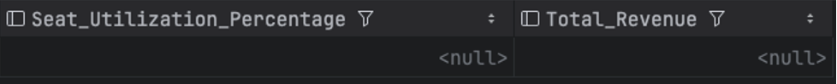

Then, database administrator inserted one ticket for this flight.

Now, the result shows that the flight with the number "XX000" is full (1/1).





When administrator tried to insert another ticket for this flight, an appropriate error message was displayed, confirming that no more tickets could be assigned to this flight.

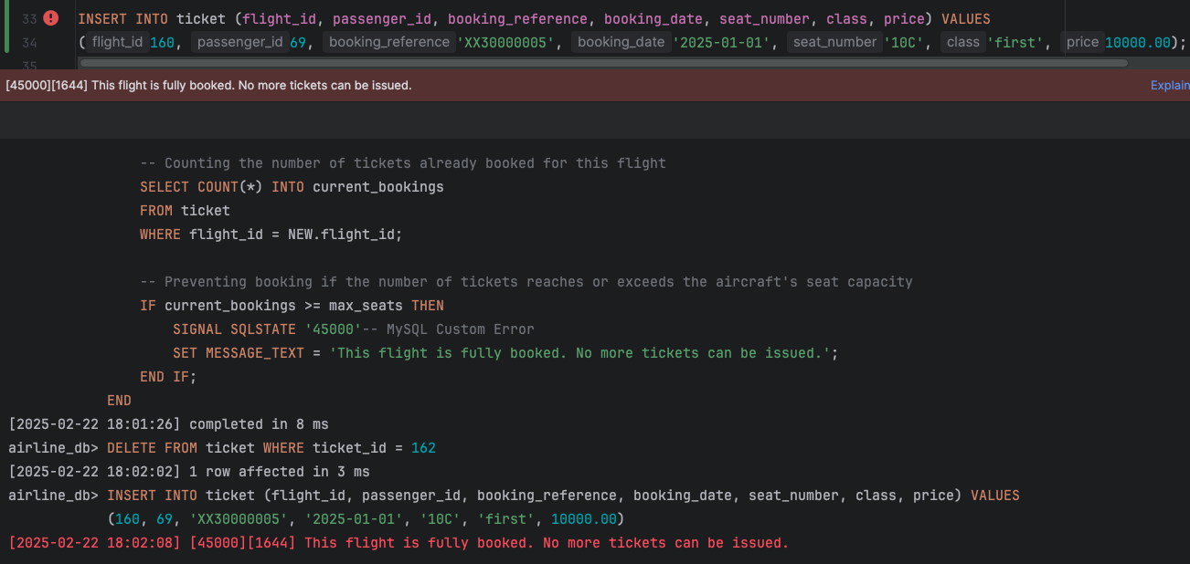

## **4.5 Trigger 2**

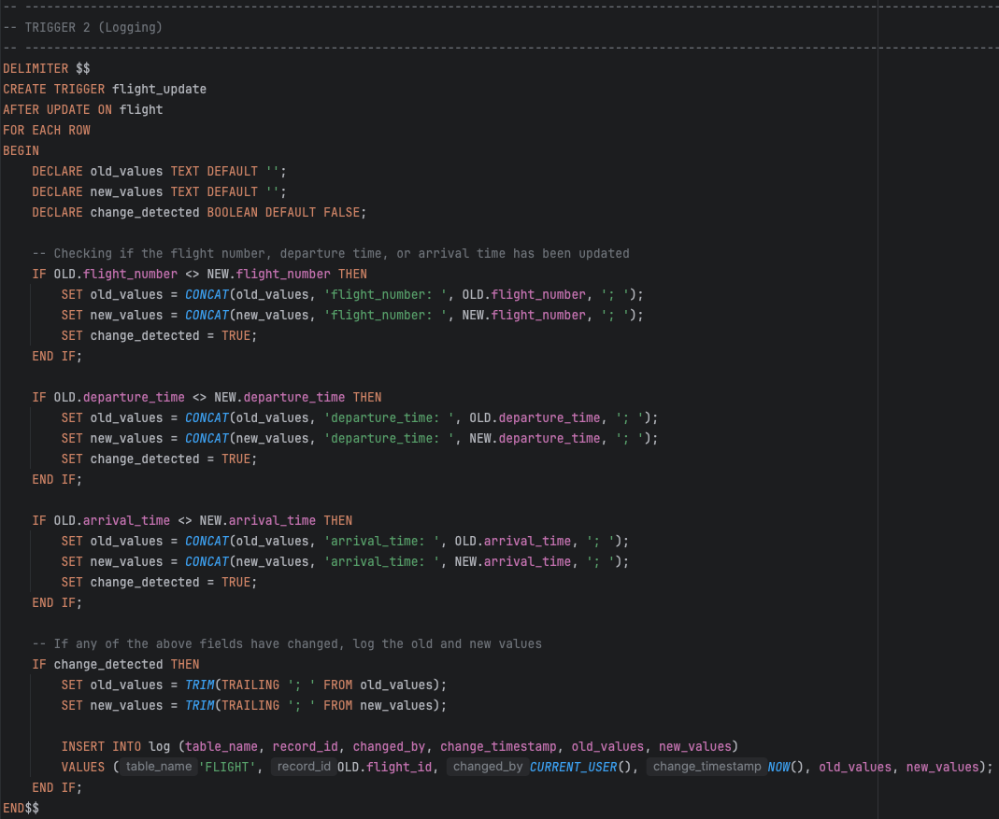

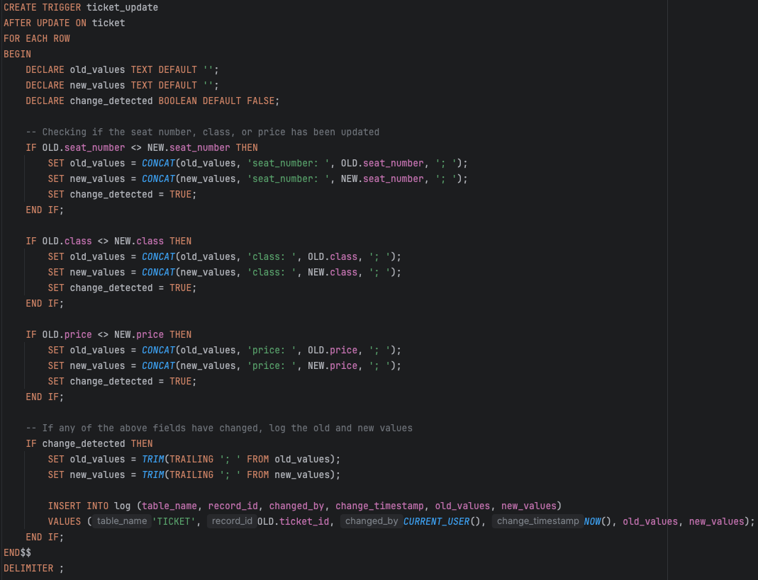

**Explanation**

Due to the word limit, the explanation for this trigger is provided in Appendix II (SQL Explanation) instead of the main report.

**Testing**

For example, the database administrator wants to update flight numbers for flight_id 1 and 2.

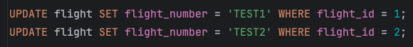

After executing the update statement, the flight_update trigger is automatically called. As a result, the log table now consists of two new records from the FLIGHT table.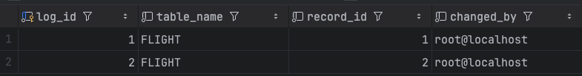

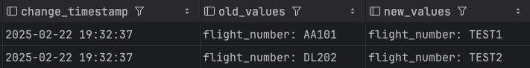

Another example would be if the database administrator wants to update some ticket details, as shown in this screenshot.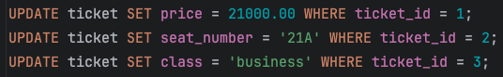

The ticket_update trigger is automatically executed after the update statement. Now, the log table consists of five records (two previous records from flight updates and three new records from ticket updates).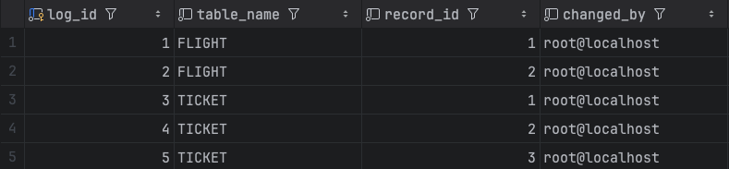

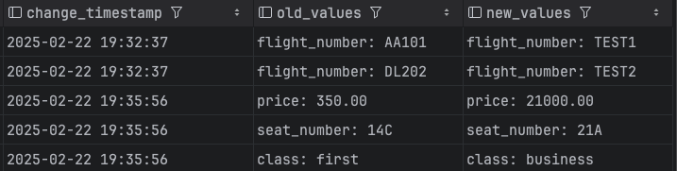

# **References**

Barnhart, C., Niaura, R., Johnson, E.L., Klabjan, D., Nemhauser, G.L. and Vance, P.H (2003). *Airline Crew Scheduling*. Available at: <https://www.researchgate.net/publication/227105914_Airline_Crew_Scheduling> (Accessed date: 6 February)  
  
Belobaba, P., Odoni, A., & Barnhart, C. (2009). *The global airline industry*. Available at: <https://www.academia.edu/40819640/THE_GLOBAL_AIRLINE_INDUSTRY> (Accessed date: 5 February)  
  
GeeksforGeeks (2025). *MySQL | Ranking Functions*. Available at: <https://www.geeksforgeeks.org/mysql-ranking-functions/> (Accessed date: 17 February)

Carlson, E. (2021). *A Guide to Understanding Airport Codes: IATA, ICAO, and LID*. Available at: <https://blog.flightaware.com/a-guide-to-understanding-airport-codes-iata-icao-and-lid> (Accessed date: 7 February)

MySQL (2025). *Case Statement*. Available at: <https://dev.mysql.com/doc/refman/8.4/en/case.html> (Accessed date: 13 February)

MySQL (2025). *Comparison Functions and Operators*. Available at: <https://dev.mysql.com/doc/refman/8.4/en/comparison-operators.html> (Accessed date: 23 February)

‌MySQL (2025). *Signal Statement*. Available at: <https://dev.mysql.com/doc/refman/8.4/en/case.html> (Accessed date: 23 February)

MySQL (2025). *String Functions and Operators*. Available at: <https://dev.mysql.com/doc/refman/8.4/en/string-functions.html#function_trim> (Accessed date: 23 February)

MySQL (2025). *WITH (Common Table Expressions)*. Available at: <https://dev.mysql.com/doc/refman/8.4/en/with.html> (Accessed date: 11 February)

MySQL Tutorial (2025). *MySQL CROSS JOIN*. Available at: <https://www.mysqltutorial.org/mysql-basics/mysql-cross-join/> (Accessed date: 17 February)  
  
W3schools (2025). *MySQL IF() Function*. Available at: <https://www.w3schools.com/SQl/func_mysql_if.asp> (Accessed date: 21 February)

OpenAI (2025). *ChatGPT*. Available at: <https://chatgpt.com/> (Accessed date: 9 February)

‌Tutorialspoint (2025). *MySQL - DECLARE Statement*. Available at: <https://www.tutorialspoint.com/mysql/mysql_declare_statement.htm> (Accessed date: 23 February)

Zanini, A. (2023). *SQL Triggers: What They Are and How to Use Them*. Available at: <https://www.dbvis.com/thetable/sql-triggers-what-they-are-and-how-to-use-them/> (Accessed date: 24 February)

# **Appendix I: Database Schema**

**Airport**

|  |  |  |
| --- | --- | --- |
| Attribute | Data Type | Description |
| airport_id {PK} | INT | Primary Key. Holds a unique number for each airport |
| name | VARCHAR(100) | Name of the airport |
| city | VARCHAR(100) | City where the airport is located |
| country | VARCHAR(100) | Country where the airport is located |
| iata_code | CHAR(3) | Unique 3-character IATA code for the airport |
| icao_code | CHAR(4) | Unique 4-character ICAO code for the airport |
| time_zone | VARCHAR(50) | Time zone in which the airport operates |

**Airline**

|  |  |  |
| --- | --- | --- |
| Attribute | Data type | Description |
| airline_id {PK} | INT | Primary Key. Holds a unique number for each airline |
| name | VARCHAR(100) | Name of the airline |
| country | VARCHAR(100) | Country where the airline is based |
| iata_code | CHAR(3) | Unique 3-character IATA code for the airline |
| icao_code | CHAR(4) | Unique 4-character ICAO code for the airline |

**Aircraft**

|  |  |  |
| --- | --- | --- |
| Attribute | Data Type | Description |
| aircraft_id {PK} | INT | Primary Key. Holds a unique number for each aircraft |
| airline_id {FK} | INT | Foreign Key. Holds a unique number that maps to the airline table |
| model | VARCHAR(100) | Model of the aircraft |
| manufacturer | VARCHAR(100) | Manufacturer of the aircraft |
| year | YEAR | Year of aircraft manufacture |
| registration_number | VARCHAR(20) | Unique registration number |
| total_seats | INT | Total number of seats |
| flight_range | INT | Maximum flight range |

**Flight**

|  |  |  |
| --- | --- | --- |
| Attribute | Data type | Description |
| flight_id {PK} | INT | Primary Key. Holds a unique number for each flight |
| airline_id {FK} | INT | Foreign Key. Holds a unique number that maps to the airline table |
| aircraft_id {FK} | INT | Foreign Key. Holds a unique number that maps to the aircraft table |
| departure_airport_id {FK} | INT | Foreign Key. Holds a unique number that maps to the departure airport |
| arrival_airport_id {FK} | INT | Foreign Key. Holds a unique number that maps to the arrival airport |
| flight_number | VARCHAR(10) | Flight number |
| departure_time | DATETIME | Scheduled departure time |
| arrival_time | DATETIME | Scheduled arrival time |
| distance | INT | Flight distance |

**Passenger**

|  |  |  |
| --- | --- | --- |
| Attribute | Data Type | Description |
| passenger_id {PK} | INT | Primary Key. Holds a unique number for each passenger |
| first_name | VARCHAR(50) | Name |
| last_name | VARCHAR(50) | Surname |
| nationality | VARCHAR(50) | Nationality |
| dob | DATE | Date of birth |
| contact_number | VARCHAR(20) | Contact number |
| email | VARCHAR(100) | Email address |
| passport_number | VARCHAR(64) | Passenger passport number |

**Ticket**

|  |  |  |
| --- | --- | --- |
| Attribute | Data Type | Description |
| ticket_id {PK} | INT | Primary Key. Holds a unique number for each ticket |
| flight_id {FK} | INT | Foreign Key. Holds a unique number that maps to the flight table |
| passenger_id {FK} | INT | Foreign Key. Holds a unique number that maps to the passenger table |
| booking_reference | VARCHAR(20) | Booking reference of the ticket |
| booking_date | DATE | Booking date of the ticket |
| seat_number | VARCHAR(5) | Seat number of the ticket |
| class | ENUM('economy', 'business', 'first') | Class of the ticket |
| price | DECIMAL(10,2) | Price of the ticket |

**Baggage**

|  |  |  |
| --- | --- | --- |
| Attribute | Data Type | Description |
| baggage_id {PK} | INT | Primary Key. Holds a unique number for each baggage |
| ticket_id {FK} | INT | Foreign Key. Holds a unique number that maps to the ticket table |
| weight | DECIMAL(5,2) | Weight of the baggage |
| type | ENUM('carry_on', 'checked') | Type of the baggage |

**Payment**

|  |  |  |
| --- | --- | --- |
| Attribute | Data Type | Description |
| payment_id {PK} | INT | Primary Key. Holds a unique number for each payment |
| ticket_id {FK} | INT | Foreign Key. Holds a unique number that maps to the ticket table |
| amount | DECIMAL(10,2) | Payment amount |
| method | ENUM('credit_card', 'debit_card', 'cash', 'bank_transfer') | Payment method |
| date | DATE | Date of the payment |

**Crew**

|  |  |  |
| --- | --- | --- |
| Attribute | Data Type | Description |
| crew_id {PK} | INT | Primary Key. Holds a unique number for each crew member |
| first_name | VARCHAR(50) | First name of the crew member |
| last_name | VARCHAR(50) | Surname of the crew member |
| dob | DATE | Date of birth of the crew member |
| contact_number | VARCHAR(20) | Contact number of the crew member |
| email | VARCHAR(100) | Email address of the crew member |
| role | ENUM('pilot', 'co_pilot', 'engineer', 'purser', 'flight_attendant') | Role of the crew member |
| experience_years | INT | Crew member years of experience |

**Flight Crew**

|  |  |  |
| --- | --- | --- |
| Attribute | Data Type | Description |
| flight_crew_id {PK} | INT | Primary Key. Holds a unique number for each flight crew |
| crew_id {FK} | INT | Foreign Key. Holds a unique number that maps to the crew table |
| flight_id {FK} | INT | Foreign Key. Holds a unique number that maps to the flight table |
| assigned_date | DATE | Date when the crew member is assigned |
| shift_start | TIME | Start time of the shift |
| shift_end | TIME | End time of the shift |

**Delay**

|  |  |  |
| --- | --- | --- |
| Attribute | Data Type | Description |
| delay_id {PK} | INT | Primary Key. Holds a unique number for each delay |
| flight_id {FK} | INT | Foreign Key. Holds a unique number that maps to the flight table |
| duration | INT | Length of the delay in minutes |
| reason | TEXT | Explanation of the delay |
| reported_time | DATETIME | Date and time when the delay was reported |

**Cancellation**

|  |  |  |
| --- | --- | --- |
| Attribute | Data Type | Description |
| cancellation_id {PK} | INT | Primary Key. Holds a unique number for each cancellation |
| flight_id {FK} | INT | Foreign Key. Holds a unique number that maps to the flight table |
| reason | TEXT | Explanation of the cancellation |
| cancellation_date | DATETIME | Date and time of the cancellation |

**Log**

|  |  |  |
| --- | --- | --- |
| Attribute | Data Type | Description |
| log_id {PK} | INT | Primary Key. Holds a unique number for each log |
| table_name | VARCHAR(50) | Name of the table where the change occurred |
| record_id | INT | Identifier of the affected record in the table |
| changed_by | VARCHAR(100) | User who made the change |
| change_timestamp | TIMESTAMP | Time when the change was made |
| old_values | TEXT | Previous values before the change |
| new_values | TEXT | New values after the change |

# **Appendix II: SQL Explanation**

**Query 1** **(Link)**

This query has two main parts. The first part creates a temporary table using a Common Table Expression (MySQL, 2025). It groups flights by season and calculates the total number of flights and revenue per season. The second part selects this information and orders it by revenue.

In the first part, the query checks the month in which each flight departed and groups it into a season: Winter, Spring, Summer, or Fall (MySQL, 2025). Then, it counts the number of flights within each season and adds up the ticket sales as revenue. If there are no tickets sold for a flight, the revenue is noted as zero. The query also makes sure to only include flights from the year 2024 (the year can be changed, the 2024 was chosen because the database has a lot of flights in this year). To get this information, the query joins the flight, aircraft, and ticket tables. A JOIN is used to get flight information, and a LEFT JOIN is used to guarantee that flights with no tickets are also returned (some flights in my database do not have any tickets). Then the results are grouped by season. The second part of the query fetches and shows the results. It chooses the season, the total number of flights, and the total revenue, then orders the seasons from most revenue to least.

**Query 2** **(Link)**

The first part creates a temporary table using a Common Table Expression (MySQL, 2025) to summarize passenger spending and flight details. The second part selects the top five highest-spending passengers based on total spending.

In the first part, the query fetches important information for each passenger. It initially fetches the passenger's ID, first name, and last name. Then it calculates the total money they spent on tickets and the total flights they travelled. The total amount spent is divided by the number of flights to get the average cost per flight. NULLIF() is used to avoid division by zero. The query also shows which airline each passenger flies on the most (it does it with the help of a subquery that calculates how many flights the passenger has flown with each airline). The airline with the most bookings is chosen as their preferred airline. Also, the query filters tickets that were booked only in 2024. Lastly, it groups by passenger ID, first name, and last name. The second part retrieves and displays the results. It selects the passenger’s ID, name, number of flights taken, average spending per flight, total spending, and preferred airline. The results are ordered by total spending (sorted in descending order). The LIMIT 5 ensures that only the top five passengers are shown.

**Query 3** **(Link)**

The first part creates a temporary table using a Common Table Expression (MySQL, 2025) to calculate ticket sales and revenue for each flight route. The second part selects and displays the top three highest-revenue flight routes, along with details about their departure and arrival airports.  
  
The Route Revenue sorts flights by their departure and arrival airport IDs. It calculates the number of tickets sold on each route and the total of the ticket prices to find total revenue. The IFNULL(SUM(t.price), 0) function is used to display flights with zero ticket sales with zero revenue as well (because some of my flights in the database do not have any tickets). The average revenue made per flight is calculated by dividing total revenue by the number of different flights on that route. The query is only considering tickets that were booked in 2023. The second part selects airport names and city details for a flight route by joining Route Revenue with the airports table twice. The first join selects the departure airport details, while the second selects the arrival airport details. The results are ordered by total revenue in descending order. The LIMIT 3 keyword makes sure that only the top three routes with the highest revenue are displayed.

**Query 4** **(Link)**

The first part creates a Common Table Expression (MySQL, 2025) called Airport Traffic, which calculates the total number of departures and arrivals for each airport in 2024. The second part selects and sorts the top five busiest airports based on total traffic.

In the first part, the query selects data from the airport and flight tables. The JOIN operation ensures that each airport is linked to flights where it appears as either a departure or an arrival location. The SUM(IF(...)) function is used to count departures and arrivals separately. If an airport matches the departure_airport_id, it increases the Departures count by 1. If it matches the arrival_airport_id, it increases the Arrivals count by 1. The results are grouped by the airport's ID, name, city, and country. The second part of the query selects the airport name, city, and country, along with the total Departures, Arrivals, and their combined Total Traffic. The results are sorted in descending order based on Total Traffic. The LIMIT 5 displays only the top five busiest airports.

**Query 5** **(Link)**

The first part creates a Common Table Expression called Airline Operations (MySQL, 2025), which calculates the number of delays and cancellations per flight for each airline in 2017. The second part selects this data to summarize the total number of flights, delays, and cancellations for each airline.

In the first part, the query selects flight and airline details by joining the flight table with the airline table. The LEFT JOIN is used to include delay and cancellation records (it ensures that even flights without delays or cancellations are considered). The COUNT() is used to calculate the number of delays and cancellations per flight. The HAVING clause ensures that only flights with at least one delay or cancellation are included in the dataset. The YEAR() function filters flights from 2017. In the second part, the query selects airline performance statistics. It counts the total number of flights operated by each airline. Then, it sums the total number of delays and cancellations across all flights. After that, it displays the delay percentage and cancellation percentage that are calculated by dividing the respective totals by the total number of flights and multiplying by 100 (to show in %). The NULLIF() function prevents division by zero in case an airline has no recorded flights. Finally, the results are sorted in descending order by the number of flights operated.

**Procedure 1** **(Link)**

This stored procedure has three parts. Firstly, a Common Table Expression (MySQL, 2025) called Airline Performance calculates the ticket sales and revenue for each airline in a specific year (in this case, the argument is 2023). It also ranks on revenue by using the RANK() function (GeeksforGeeks 2025), with airlines ranked from highest to lowest revenue. The second part creates another table called Total Market that calculates the overall ticket sales and overall revenue of all the airlines. This is to compare the performance of each airline against the overall market. The third part presents the final report. It selects each airline’s rank, name, total tickets sold, and total revenue, then calculates the airline’s market share percentage for both ticket sales and revenue. The CROSS JOIN ensures that each airline's statistics are compared with the overall market totals (MySQL Tutorial, 2025).

**Procedure 2** **(Link)**

This procedure takes a flight number as input and is structured into three main parts. The first part selects the total number of seats for the given flight by joining the flight and aircraft tables. The second part calculates ticket sales and total revenue by counting the number of tickets sold and summing their prices. The final part combines these details to present a full flight performance summary, including seat utilization percentage, which helps determine how efficiently seats were filled. The query first creates a Common Table Expression (MySQL, 2025) called Flight Info that selects the flight ID, number, and total seat capacity. Then, Ticket Stats counts the tickets sold and calculates total revenue. The main query joins both results, displaying flight details, ticket sales, revenue, and seat utilization percentage. A LEFT JOIN is used to ensure that flights with zero sales are included.

**Procedure 3** **(Link)**

Flight Category divides flights as either domestic or international based on whether the departure and arrival airports are in the same country. It selects the flight ID, airline name, and flight type using an IF condition (W3schools, 2025) to check if both airports belong to the same country. The query only includes flights from the year specified by the procedure’s input parameter. Category Summary displays the total number of flights for each flight type. It counts how many domestic and international flights an airline operated in the selected year and groups them accordingly. Total Flights calculates the overall number of flights for that airline in the given year. This helps in computing the percentage of domestic and international flights out of the total flights. Finally, the main query displays the flight type, total number of flights, and flight percentage share for each category. The results are sorted in descending order based on the number of flights.

**Trigger 1** **(Link)**

The overbooking trigger ensures that passengers cannot book more tickets than there are seats available on the aircraft. It runs before inserting a new ticket into the database. It initially gets the maximum number of available seats for the aircraft assigned to the flight (‌Tutorialspoint, 2025). Then it counts the existing sold tickets for the flight. When the current bookings are equal to or more than available seats, the trigger raises a custom SQL error (SQLSTATE '45000') (‌MySQL, 2025). This will prevent the insertion of the new ticket. This trigger guarantees that there can be no overbooking, avoiding business problems and unhappy customers because there are no seats.

**Trigger 2** **(Link)**

The flight_update and ticket_update triggers log any modifications to the flight or ticket tables. They executed after an update occurred on the respective table. The OLD and NEW keywords are used to compare the previous and updated values of key attributes (Zanini, 2023). The <> symbol checks if a column’s value has changed by comparing OLD.column_name with NEW.column_name (‌‌MySQL, 2025). If any difference is detected in attributes such as flight number, departure time, arrival time (for flights), or seat number, class, price (for tickets), the trigger records both the old and new values in a log table. To make logged data look cleaner, the TRIM(TRAILING '; ' FROM old_values) removes any unnecessary trailing characters (like extra semicolons or spaces) (‌‌‌MySQL, 2025).